

Technical Protocol

Comparisons of standards for liquid flow rates
between 6 kg/h to 20000 kg/h

EURAMET identifier: 1805
EURAMET Supplementary comparison
BIPM KCDB identifier: EURAMET.M.FFxxx

Co-ordinator / pilot
INRIM/Italy
Co-pilot
RISE/Sweden

June 2026
Contents
1 Introduction 3
2 Participants and planning 3
3 Transfer standards 7
3.1 Output Configuration 7
3.2 Pictures of the transfer standards and flight case 8
3.3 Electrical connections 10
4 Measurement procedure and calibration protocol 10
4.1 Measured quantity 10
4.2 Calibration protocol and measurement conditions 12
4.3 Zeroing procedure 13
4.4 Zero instability 14
4.5 Transfer standard CMFS015M 14
4.6 Transfer standard CMFS050M 15
4.7 Transfer standard CMFS100M 16
4.8 Reporting the results 17
5 Measurement results 17
5.1 Uncertainty u(ε_{lab, i}) of laboratory reported value ε_{lab, i} 18
5.2 Determination of Comparison Reference Value (CRV) and its uncertainty 18
5.3 Determination of normalized degree of equivalence E_{N, i} - Evaluation criterion A 19
5.4 Determination of calibration conclusiveness - Evaluation criteria B and D 20
5.5 Final evaluation procedure of comparison data for decision table 21
6 References 21
7 Appendix 23

Introduction
The CIPM Mutual Recognition Arrangement (CIPM MRA) is the framework through which National Metrology Institutes demonstrate the international equivalence of measurement standards. In this context, the BIPM publishes a list of Calibration and Measurement Capabilities (CMC-lists) of the institutes which have signed the MRA. However, calibration services can only be included if a quality management system according to ISO standard 17025 is established. However, quality assurance and confidence in the capabilities of other laboratories can be ensured by successful participation in a comparison in which the degree of equivalence with other national metrology institutes or calibration laboratories is determined.
A comparison is organized to determine the degree of equivalence of standards for liquid flow rates under static load changes in the range of 6 kg/h to 20 000 kg/h.
Three Coriolis Mass Flow Meters will be used as Transfer Standards (TS):
- TS1: Coriolis Mass Flow Meter, Emerson CMFS015M, for flow rates in range from 6 kg/h to 300 kg/h, at 20 °C
- TS2: Coriolis Mass Flow Meter, Emerson CMFS050M, for flow rates in range from to 600 kg/h to 5000 kg/h, at 20 °C and 50 °C; and in range from to 600 L/h to 5000 L/h, at 20 °C and 50 °C
- TS3: Coriolis Mass Flow Meter, Emerson CMFS10M, for flow rates in range from to 5000 kg/h to 20000 kg/h, at 20 °C

Participants and planning
The participants and planning are shown in Table 1. Each laboratory is requested to arrange transportation to the next institute.
Each laboratory is allocated a total of one month: three weeks to perform the measurements and one week to ship the TS to the next laboratory.
After the transfer standards arrive, the participating institute shall inform the pilot institutes by e-mail (a.malengo@inrim.it; r.romeo@inrim.it, oliver.buker@ri.se). Immediately after receipt, a visual inspection should be performed. The participating institute will check the instruments for any damage.
Each participating laboratory, as soon as calibrated, will send the TS to the next laboratory according to the circulation scheme (Table 1), informing the receiving laboratory and the pilot laboratory.
The travelling standards are placed in appropriate containers provided by the pilot laboratory.
The package will be transported by courier or directly by the laboratory staff.
The package will be equipped with a warning: To be opened only by laboratory staff.
After the arrival of the package, the laboratory will inform the pilot laboratory without delay, indicating the date of arrival, the status of the package, and its contents.
Each participating laboratory bears its own costs for the transportation of the travelling standards to the next laboratory and any customs charges. The participants are responsible for completing local customs formalities. It is advised to include in each shipment order an insurance covering the hardware cost of 15 000 €.
ATA Carnet will be provided to laboratories that request it, please ensure that the carnet is presented to the customs authorities and stamped correctly.
Each laboratory must complete all customs formalities as soon as possible to avoid delays in circulation.
Table 1: Participants and time schedule.
Institute | Country | Shipping address | Contact/mail/phone | Remarks | Date
INRIM | Italy | INRIM  Strada delle Cacce, 91  10135 Torino  Italy | Andrea Malengo  Raffaella Romeo  a.malengo@inrm.it  r.romeo@inrim.it | Only CMFS015M | 2026 From  01 June to  28 June
LNEC-UHM | Portugal | Laboratório Nacional de Engenharia Civil, Av. do Brasil 101, 1700-066 Lisboa Portugal | Álvaro Ribeiro  asribeiro@lnec.pt |  | 2026 From  29 June to  31 July
DTI | Denmark | Danish Technological Institute  Kongsvang Allé 29,  Building 14, Port A  8000  Aarhus C  Denmark | Mikkel Nørgaard Bollesen mikb@teknologisk.dk |  | 2026 From  03 August to  30 August
VTT MIKES | Finland | National Metrology Institute VTT MIKES  Tehdaskatu 15, Puristamo 9P19  FI-87100 Kajaani  Finland | Huovinen Mika Mika.Huovinen@vtt.fi |  | 2026 From  01 September to  30 September
BEV | Austria | BEV - Bundesamt für Eich- und Vermessungswesen,  Arltgasse 35,  1160 Vienna,  Austria | Berkmann Claudia Claudia.Berkmann@bev.gv.at |  | 2026 From  01 October to  31 October
CMI | Czechia | Czech Metrology Institute  Okruzni 31,  63800 Brno  Czechia | Miroslava Benkova  miroslava.benkova@cmi.gov.cz |  | 2026 From  01 November to  30 November
NEL | United Kingdom | James Young Building  TÜV SÜD National Engineering Lab  Scottish Enterprise Technology Park,  Reynolds Ave  G75 0AF,  United Kingdom. | Chris Mills Chris.Mills@tuvsud.com | No  CMFS015M | 2026 From  01 December to  8 January
METAS | Switzerland | Federal Institute of Metrology  Hugo Bissig  Lindenweg 50  CH-3003 Bern-Wabern  Switzerland | Hugo Bissig  Hugo.Bissig@metas.ch | Only CMFS015M | 2026 From  01 December to  8 January
INRIM | Italy | NRIM  Strada delle Cacce, 91  10135 Torino  Italy | Andrea Malengo  Raffaella Romeo  a.malengo@inrm.it  r.romeo@inrim.it |  | 2027 From  11 January to  07 February
JV | Norway | JustervesenetFetveien  Fetveien 99  2007 Kjeller  Norway | Maxime Mussard mmu@justervesenet.no |  | 2027 From  08 February to  8 March
RISE | Sweden | RISE AB  Oliver Büker / 105104  Brinellgatan 4  SE - 504 62 Borås  SWEDEN | Oliver Büker  oliver.buker@ri.se |  | 2027 From  09 March to  31 March
PTB | Germany | Physikalisch-Technische Bundesanstalt  Fachbereich 1.5 Flüssigkeiten  Bundesallee 100  38116 Braunschweig  Germany | Corinna Kroner  corinna.kroner@ptb.de |  | 2027 From  05 April to  30 April
CETIAT | France | CETIAT  Laboratoire Débitmétrie Liquide  Domaine Scientifique de la Doua  54 boulevard Niels Bohr  69100 Villeurbanne  France | Kevin Romieu  kevin.romieu@cetiat.fr |  | 2027 From  03 May l to  30 May
MIRS | Slovenija | Urad RS za meroslovje  Tkalska ulica 15  3000 Celje  Slovenija | Matjaž Gaber Matjaz.Gaber@gov.si | No  CMFS100M | 2027 From  01 June to  27 June
INRIM | Italy | INRIM  Strada delle Cacce, 91  10135 Torino  Italy | Andrea Malengo  Raffaella Romeo  a.malengo@inrm.it  r.romeo@inrim.it |  | 2027 From  01 July to  31 July
VSL | The Netherlands | VSL  Walrusweg 5  Rotterdam, 3199ME  The Netherlands | Erik Smits  fsmits@vsl.nl |  | 2027 From  02 August to  29 August
SMU | Slovakia | Slovenský metrologický ústav (SMÚ), Karloveská 63, 841 04 Bratislava,  Slovakia | Sammarah George  sammarah@smu.gov.sk |  | 2027 From  01 September to  30 September
LEI | Lithuania | Lithuanian Energy Institute, Breslaujos str. 3, LT-44403 Kaunas,  Lithuania | Andrius Bončkus andrius.bonckus@lei.lt |  | 2027 From  04 October to  30 October
INM | Moldavia | Institutul Naţional de Metrologie  Strada Eugen Coca 28, Chișinău,  Moldavia | Victor Grușcă victor.grusca@inm.gov.md |  | 2027 From  01 November to  28 November
UKRMETRTEST  STANDART | Ukraine | SE UKRMETRTESTSTANDART  4 Metrologichna str. 4, Kyiv, 03143,  Ukraine | Yaroslava Volynska yvolynska@ucsm.com.ua |  | 2027 From 01 December to  31 December
INRIM | Italy | INRIM  Strada delle Cacce, 91  10135 Torino  Italy | Andrea Malengo  Raffaella Romeo  a.malengo@inrm.it  r.romeo@inrim.it |  | 2028 From  03 January to  31 January

Transfer standards

For the comparison INRIM provides three transfer standards, details are shown in the following table.

Table 2: The transfer standards used for the comparison.
Manufacturer | EMERSON |  | EMERSON |  | EMERSON
Model | CMFS015M |  | CMFS050M |  | CMFS100M
Serial number | 12176384 |  | 15060646 |  | 15061260
Fitting | 1/4" threaded fitting |  | DN25 flanged pipe |  | DN50 flanged pipe
 | with flanges supplied EN 1092 01 DN25 |  | EN 1092-01/11/ DN25/15/ PN40 |  | EN 1092-01/11D/ DN50/ PN40
Dimensions
Face-to-face flanges | 38 | cm | 48 | cm | 59 | cm
Dimension from centreline to bottom | 11 | cm | 18 | cm | 22 | cm
Dimension from centreline to top | 21 | cm | 22 | cm | 25 | cm

The CMFS015M meter is equipped with small-diameter inlet and outlet process connections. This meter cannot be installed in calibration rigs that rely on a flange clamping system to achieve a seal. For these rigs, the meter must be mounted off-line. It can be connected using threaded fittings or with the supplied flanges.

Output Configuration

The output configuration is shown in the following table.
Table 3: Output configuration.
Model | CMFS015M | CMFS050M | CMFS100M
Calibration | Mass totalized | Mass and Volume totalized | Mass totalized
Output A | 4–20 mA  for zero verification  4 mA: -0.1 kg/h  20 mA: +0.1 kg/h | 4–20 mA  for zero verification  4 mA: -1 kg/h  20 mA: +1 kg/h | 4–20 mA  for zero verification  4 mA: -2 kg/h  20 mA: +2 kg/h
Output B | - | Digital pulse  0.5 mL/pulse | -
Output C | Digital pulse  0.2 g/pulse | Digital pulse  0.5 g/pulse | Digital pulse  3 g/pulse
Measurand | Totalized mass error | Totalized mass error | Totalized mass error
Measurand |  | Totalized volume error
For all meters, the mass flow cutoff threshold is set to zero. The volume flow cutoff is also set to zero for the CMFS050M.
For the CMFS015M only, the meter factor is set to 1.005; for the other two, it is 1.

Pictures of the transfer standards and flight case
The transfer standards CMFS015M and CMFS050M (Figure 1) are transported in a common flight case (Figure 2).
Dimension: (40 x 50 x 80) cm
Weight: 40 kg
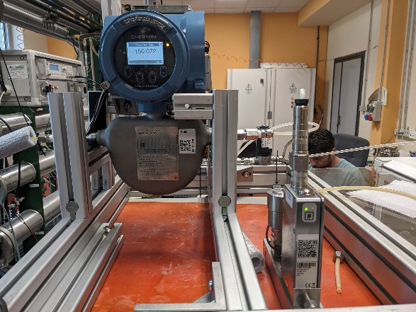 | 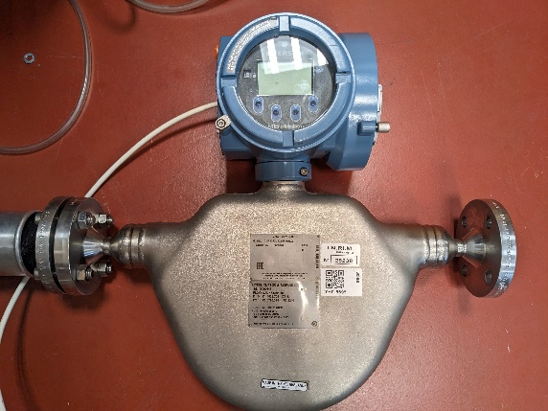
Figure 1: Pictures of CMFS015M (left) and CMFS050M (right).

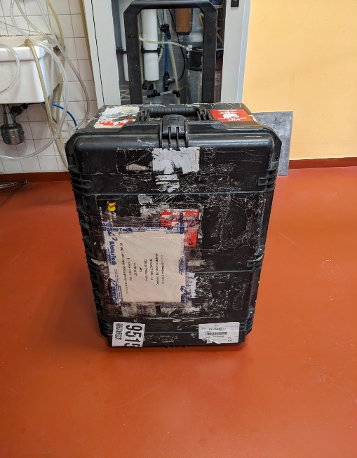
Figure 2: Picture of the flight case.

The transfer standard CMFS100M (Figure 3) is transported in a special package in a cardboard box (Figure 4).
Dimension: (60 x 65 x 30) cm
Weight: 20 kg

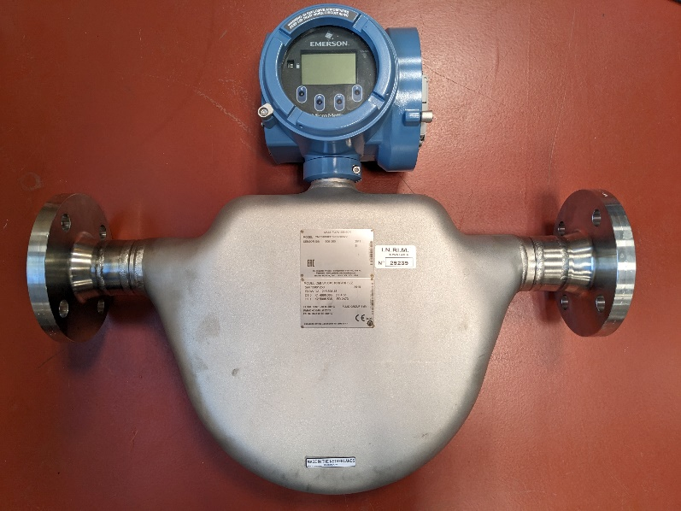
Figure 3: Picture of the CMFS100M.
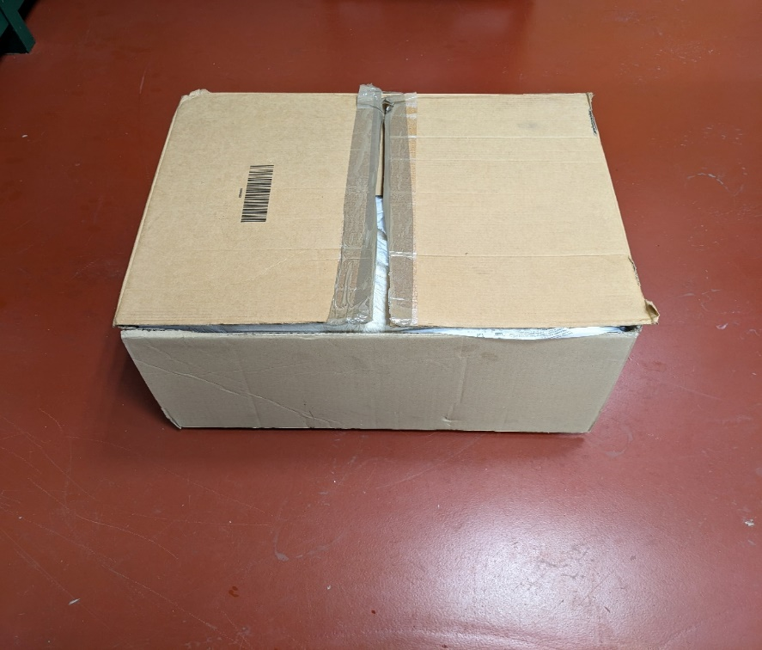
Figure 4: Picture of the cardboard box.

Electrical connections

Power Supply
Micro Motion transmitters are equipped with an auto-switching AC/DC input that automatically detects voltage. Connect the power supply to the terminals located under the protective cover.
Digital and analog outputs
Table 4: Connector terminal block description.
Channel | Terminals | Output Type | Function
A | 1 (+) 2 (-) | Analog  4-20 mA | Mass flow rate
B | 3 (+) 4 (-) | Digital | Volume Pulse Output, only for CMFS050M
C | 5 (+) 6 (-) | Digital | Mass Pulse Output

The outputs can be configured as active or passive. The configuration was checked before connecting the outputs; details are provided in the Appendix.

Measurement procedure and calibration protocol

Measured quantity
The comparison is based on the measurement of the relative error in the totalized mass and volume (only for the CMFS050M) of the transfer standards.
The mass relative error $ε_{m}$ (%) is defined as:
$ε_{m}=\frac{m_{DUT }- m_{ref}}{m_{ref}} ∙ 100\%$ (1)
where $m_{DUT }$ is the totalized mass by the meter and $m_{ref}$ is the reference totalized mass.
For meter CMFS050M, the relative error for the volume is also determined
The volume relative error $ε_{V}$ (%) is defined as:
$ε_{V}=\frac{V_{DUT }- V_{ref}}{V_{ref}} ∙ 100\%$ (2)
where $V_{DUT }$ is the totalized volume by the meter and $V_{ref}$ is the reference totalized volume.
The errors have to be determined at the flow rate points defined in Sections 4.5, 4.6 and 4.7, at a temperature of approximately 20 °C. Calibration at 50 °C is required only for the CMFS050M meter.
Since the flow meters under test are affected by changes in fluid temperature and pressure, corrections must be made to account for errors under specified conditions.
The conditions under which measured errors must be expressed are as follows:
- The reference pressure $p_{ref}$ at which errors must be calculated is 3 bar (absolute)
- The reference temperature $t_{ref}$ at which errors must be calculated are 20 °C and 50 °C for the calibration of the CMFS050M meters at 50 °C.
The coefficients of variation with respect to temperature dependence are shown in Table 5. The values were specified by the manufacturer. The corrections for temperature are negligible if the temperatures are (20 ± 5) °C and (50 ± 5) °C, and considering that a zero-flow calibration is performed before conducting the measurements.
With regard to pressure dependence, the coefficients of variation for mass flow rate ${ C}_{m}$ and density measurement ${ C}_{ρ}$ are shown in the Table 5. The effect of pressure on density is only relevant for the CMFS050M meter, where the volume error is determined. These values were determined experimentally and confirmed the manufacturers' specifications.
Since the pressure measurement affects the corrections applied to the measurements, it is recommended that the pressure measurement be performed with an expanded uncertainty of less than 0.1 bar.
Table 5. Coefficients of variation for the temperature and pressure.
 | CMFS015M | CMFS050M | CMFS100M
coefficients of variation for mass flow | No effect | ${ C}_{m}=$ 0.014 % per bar  $${ u(C}_{m})=0.001 \%$$ | ${ C}_{m}$ = 0.026 % per bar  $${ u(C}_{m})=0.002 \%$$
coefficients of variation for density | Not required | ${ C}_{ρ}$= 0.36 kg/m³ per bar  $${ u(C}_{ρ})=0.01 kg/m^{3}$$ | Not required
coefficients of variation for temperature | ±0.0002 % per °C | ±0.0001 per °C | ±0.0001 per °C

Correction for pressure effects for the mass
The correction of the totalized mass reading $m_{read}$ on the meter, obtained by counting the pulses in each test, must be performed as follows
$m_{DUT}=m_{read}[1+C_{m}(p-p_{ref})]$ (3)
Where $p$ is the upstream pressure of the meter (absolute in bar)
This value is to be used to calculate the mass error in Equation 1.
Correction for pressure effects for volume (only DN15)
Since the volume recorded by the meter depends on the density measurement, which is influenced by pressure, the following procedure is used:
For each test, simultaneously record the pulse counts for both mass and volume, from which the totalized mass reading $m_{read}$ and the totalized volume reading $V_{read}$ are determined
The average density measured by the meter ${}_{read}$during the test is therefore:
${}_{read}=\frac{m_{read}}{V_{read}}$ (4)
then convert this measurement to the reference pressure $p_{ref}$ to obtain ${}_{DUT}$ , according to the equation
$ρ_{DUT}=ρ_{read}+C_{ρ}\left(p-p_{ref}\right)$ (5)
As in the case of mass measurements, correct the reading $m_{read}$ for pressure according to the equation 3, to obtain $m_{DUT}$.
The volume measurement corrected for the reference pressure $V_{DUT}$ is therefore obtained as
$V_{DUT}=\frac{m_{DUT}}{ρ_{DUT}}$ (6)
This value is to be used to calculate the mass error using Equation 2.
For the exclusive purpose of analyzing the results, it is required to report the error observed on the density
$ε_{}=\frac{{}_{DUT }- {}_{ref}}{{}_{ref}} ∙ 100\%$ (7)

Calibration protocol and measurement conditions
In this section, the calibration protocol is described, and the range of measurement conditions is provided.
The participating laboratories ensured the following conditions during the measurements:
- working fluid temperature: (20 ± 5) °C and (50 ± 5) °C only for the meter CMFS050M
- ambient temperature: (20 ± 5) °C
- ambient humidity: from 30 % to 80 %
- absence of free air in the measuring line of the standard.
After installing the meters on the test bench, it was necessary to stabilise the bench temperature and allow it to flow for at least one hour before beginning the calibration.
Please read the information in the Appendix regarding the use of the transmitter

Zeroing procedure
Coriolis flowmeters must be regularly zeroed with zero flow. The procedure for performing zeroing is shown in the Appendix.
Although the meter also allows for a zero check, the meter zeroing procedure should be performed. The time set for zeroing the meters is 180 s.
An approximate check of the zero setting can be performed by reading the mass flow rate on the instrument display.
The 4-20 mA output allows for the accurate verification of the flow rate measurement when no flow is present. It is recommended to perform the test for at least 120 s.
The measurement range of the analog output has been set to a narrow range to ensure accurate measurement.
The zero-point measurement can be used to correct the reading; however, tests have shown that if the zero-adjustment procedure is performed regularly, corrections are unnecessary.
As described in Section 4.4, zero stability may affect the measurements at low flow rates on the CMFS015M meter. For this meter, at flow rates of 6 kg/h and 20 kg/h, it is recommended to adjust or verify the zero every 5 tests. For other meters, it is usually sufficient to perform a zero adjustment every 2 h.

Zero instability
Zero-point instability tests were performed at zero flow rate by recording the measured flow rate via the 4–20 mA analog output.
The tests conducted showed that the zero instability of the meters is as follows:
Table 6: Zero-point instability test results.
Model | Standard deviation in kg/h | Standard deviation of the mean of 5 repetitions in kg/h | Maximum difference between the means of 5 repetitions in kg/h | Uncertainty of instability  in kg/h (u k=1)
CMFS015M | 0.02 | 0.0015 | 0.0025 | 0.007
CMFS050M | 0.20 | 0.033 | 0.05 | 0.014
CMFS100M | 0.30 | 0.044 | 0.07 | 0.02

At low flow rates, zero instability affects the measurement repeatability.
There are no significant effects for CMFS050M and CMFS100M, for example for the CMFS050M at the minimum flow rate of 600 kg/h the standard deviation increase of about 0.033/600 = 0.005% and for the CMFS100M at 5000 kg/h 0.044/5000= 0.0009 %.
For the CMFS015M meter, zero stability does not normally affect the measurements unless the flow rate is below 50 kg/h.
For the meter CMFS015M the increase could be significant, at 20 kg/h is about 0.0015/20 = 0.0075% and at 6 kg/h is about 0.0015/6 = 0.025 %
Therefore, for flow rates of 6 kg/h and 20 kg/h, it is suggested to perform the test for a duration of at least 120 s, and 180 s is recommended.
The averages obtained from the 5 repetitions may differ slightly from each other. The maximum variations observed are shown in Table 6. Because of this effect, an uncertainty due to zero instability is assigned, which is considered in the uncertainty u_{TS} (Section 6), the values are shown in Table 6.

Transfer standard CMFS015M
Please note that this meter cannot be installed on benches where sealing is achieved by applying pressure to the flanges.
The calibration process should be performed in accordance with your internal calibration procedure. However, for flow rates of 6 kg/h and 20 kg/h, it is recommended to use times longer than 120 s; if the laboratory uses shorter times, it must indicate this in the report.
The following requirements must be fulfilled:
- Install, purge, and warm-up the transfer standard using your internal procedures.
- Close the valves upstream and downstream of the transfer standard and perform the zero adjustment. Record the flow rate indicated by the analog output of the flow meter recorded for a period long enough to check its stability (at least 120 s).
- Perform static calibration (constant flow rate) with water at a temperature of (20 ± 5) °C. Each point must be measured 5 times.
  - 6 kg/h
  - 20 kg/h
  - 50 kg/h
  - 150 kg/h
  - 300 kg/h
Record the upstream pressure $p$ and temperature during the tests.
From the pulse count and the pressure $p$, calculate $m_{DUT}$ using the equation 3.
- After taking the measurements, close the valves upstream and downstream of the transfer standard. Then record the indication of the flow meter with no flow to check for deviation.
At flow rates of 6 kg/h and 20 kg/h, it is recommended to adjust or record the zero after every five tests. For the other flow rates, the zero drift is less significant, and the zero check can be performed after approximately 2 h of testing.
The expected changes in zero are listed in Table 6.
If necessary, the recorded zero values can be used to correct the measurements.

Transfer standard CMFS050M
Perform the calibration in accordance with your internal calibration procedure. The following requirements must be fulfilled:
- Install, purge, and warm-up the transfer standard using your internal procedures.
- Close the valves upstream and downstream of the transfer standard and perform the zero adjustment. Record the flow rate indicated by the analog output of the flow meter recorded for a period long enough to check its stability (at least 120 s).
- Perform static calibration (constant flow rate) with water at a temperature of (20 ± 5) °C. Each point must be measured 5 times.
  - 600 kg/h
  - 1000 kg/h
  - 2000 kg/h
  - 3000 kg/h
  - 5000 kg/h
Record the upstream pressure $p$ and temperature during the tests.
From the pulse count and the pressure $p$, calculate $m_{DUT}$ using the equation 3.

- After taking the measurements, close the valves upstream and downstream of the transfer standard. Then record the indication of the flow meter with no flow to check for deviation.
For this meter, the zero check can be performed after approximately 2 h of testing.
The expected changes in zero are listed in Table 6.
If necessary, the recorded zero values can be used to correct the measurement.
Volume tests must be performed at the same flow rates as those specified for the mass tests.
For the volume test, it is necessary to simultaneously record both the totalized volume and mass pulses. From these two measurements, the average density value is obtained, which must be used to calculate the volume, as described in Section 4.1. For the volume tests, it is also necessary to record the average reference density of the water used in the test.
Therefore, it is recommended to perform both mass and volume calibrations simultaneously.
For this meter, the measurement error should also be determined at a water temperature of 50 °C, at the same flow rates as those measured at 20 °C, and using the same procedure as described above.

Transfer standard CMFS100M
Perform the calibration in accordance with your internal calibration procedure. The following requirements must be fulfilled:
- Install, purge, and warm-up the transfer standard using your internal procedures.
- Close the valves upstream and downstream of the transfer standard and perform the zero adjustment. Record the flow rate indicated by the analog output of the flow meter recorded for a period long enough to check its stability (at least 120 s).
- Perform static calibration (constant flow rate) with water at a temperature of (20 ± 5) °C. Each point must be measured 5 times.
  - 5000 kg/h
  - 7000 kg/h
  - 10000 kg/h
  - 15000 kg/h
  - 20000 kg/h
Record the upstream pressure $p$ and temperature during the tests.
From the pulse count and the pressure $p$, calculate $m_{DUT}$using the equations 3.
For this meter, the zero check can be performed after approximately 2 h of testing.
The expected changes in zero are listed in Table 6.
If necessary, the recorded zero values can be used to correct the measurement.

Reporting the results
The parameters to be reported are listed in Table 7.
The clear indication of the determination of the uncertainty of the reference flow is a prerequisite. In addition, the results should be sent to the pilot laboratories within one month of the tests being carried out. Furthermore, the participants are requested to use the table in the Excel sheet to report the individual measurement results. The table has the following layout:
Table 7: Measurement results – for each TS and flow rate.
Test number | 1 | 2 | 3 | 4 | 5
Reference flow / kg h⁻¹
Test duration /s
Mean upstream pressure / bar
Uncertainty upstream pressure (k=2) / bar
Mean water temperature / °C
Flow rate at zero flow /kg h⁻¹ (if necessary)
Correction of $m_{read}$ due to zero flow / g (if necessary)
TS Totalized mass $m_{read}$/ g
TS Totalized mass $m_{DUT}$/ kg
Reference Totalized mass $m_{ref}$ / kg
Correction for $V_{read}$ due to zero flow/ L (if necessary)
TS Totalized Volume $V_{read}$/ L
TS mean density $ρ_{read}$/ kg m⁻³
TS mean density $ρ_{DUT}$/ kg m⁻³
Reference mean density $ρ_{ref}$/ kg m⁻³
Mean density relative error / %
TS Totalized Volume $V_{DUT}$/ L
Reference Totalized mass $V_{ref}$ / L
Mass relative error / %
Mean mass relative error / %
Standard deviation of the mean error / %
Lab expanded uncertainty mean mass relative error / %
Volume relative error / %
Mean volume relative error / %
Standard deviation of the mean error / %
Lab expanded uncertainty mean volume relative error / %

Measurement results
The comparison reference value (CRV) will be determined for all individual flow points and will be determined based on the weighted average from all individual laboratories. All results will be compared with this reference value. The chi-squared test will be used to identify outliers. The procedure described in [1] will be used.
The pilots and co-pilots will provide the uncertainty $u_{TS}$ of the transfer standards, which includes the long-term instability of the standards themselves, their pressure sensitivity, their temperature sensitivity, and zero instability.

Uncertainty u(ε_{lab, i}) of laboratory reported value ε_{lab, i}
As described in [1], [2] and [3], the uncertainty of the reported value $ε_{lab, i}$ includes uncertainties introduced by the participant’s flow reference $u_{lab, i}$ by the transfer meter $u_{TS}$ and by the repeatability of the reported value (Equation (8)). The used input parameters of $u_{lab, i}$ do represent the claimed uncertainty values of the laboratories, which were under evaluation during this comparison. As values for $u_{lab, i}$ the expanded laboratory uncertainty are used. Uncertainty calculations of $u_{TS}$ are based on the discussions in Chapter 5, final values of $u_{TS}$. The term s/$\sqrt{n}$ represents the repeatability of measurements in the participants laboratory and are based on reported calibration results.
$$u\left(ε_{lab,i}\right)=\sqrt{{ u}_{lab,i}^{2}+u_{comp}^{2}}=\sqrt{u_{lab,i}^{2}+u_{TS}^{2}+{\left(\frac{s}{\sqrt{n}}\right)}^{2}}$$ | (8)

where:
$u\left(ε_{lab,i}\right)$ Uncertainty of reported meter error of laboratory i (%)
$u_{lab, i}$ Uncertainty of laboratory reference (%)
$u_{comp}$ Uncertainty of transfer meter measurements (%)
$s$ Standard deviation of the mean of measurements at one flowrate point (%)
$n$ Number of calibrations at one flowrate point (-)
All values of $u$ are valid for k = 1.

Determination of Comparison Reference Value (CRV) and its uncertainty
The CRV is calculated separately for each flow rate, following Procedure A in [4]. The determination of CRV includes a consistency check according to [5]. The reference value y is calculated as the weighted mean error of the participating laboratories, including the standard uncertainties u(ε _{lab,i}) of the measurements as the weights:
$$y=\frac{\left(\frac{ε_{lab1}}{u_{ε,lab 1}^{2}}+\frac{ε_{lab2}}{u_{ε,lab 2}^{2}} + … + \frac{ε_{lab i}}{u_{ε,lab i}^{2}} \right)}{\left(\frac{1}{u_{ε,lab 1}^{2}}+\frac{1}{u_{ε,lab 2}^{2}} + … + \frac{1}{u_{ε,lab i}^{2}}\right)}$$ | (9)

where $y$ is the reference value of the comparison (%).
The standard uncertainty $u_{y}$ is given with:
$$\frac{1}{u_{y}^{2}}=\frac{1}{u_{ε,lab 1}^{2}}+\frac{1}{u_{ε,lab 2}^{2}}+ … + \frac{1}{u_{ε,lab i}^{2}}$$ | (10)

where $u_{y}$ is the standard uncertainty of y with k=1 (%).
The expanded uncertainty of $y$ for $k=2$ (95% coverage probability) is calculated with:
$$U\left(y\right)=2∙u_{y}$$ | (11)

Finally, the chi-squared test is applied to determine whether the determined errors and accompanying uncertainties can be expected based on a Gaussian distribution. If so, y is accepted. The chi-squared test is defined as follows:
$$χ_{obs}^{2}=\sum_{i=1}^{n}{{\left(\frac{ε_{lab i}-ε_{RV}}{u\left(ε_{lab i}\right)}\right)}^{2}}$$ | (12)

where $χ_{obs}^{2}$ is the observed chi-squared value.
The degrees of freedom $υ$ are estimated with:
$$υ=n_{i}-1$$ | (13)

where $n_{i}$is the number of evaluated laboratories.
For data evaluation, the CHIINV(0.05;v) function of MS Excel is used. The consistency check fails if CHIINV(0.05;v) gives values < than $Χ_{obs}^{2}$. Note, here $u\left(ε_{lab i}\right)$ is the standard uncertainty (k = 1). The set of measurement results for a certain flow point is accepted only when:
$$Pr\left\{Χ_{v}^{2}>Χ_{obs}^{2}\right\}<0.05$$ | (14)

where $Χ_{v}^{2}$ is the chi-squared test value.
If consistency check of Equation (1414) passes, $y$ is accepted as the Comparison Reference Value $ε_{CRV}$ and $U(y)$ is accepted as the expanded uncertainty $U\left(ε_{CRV}\right)$. If the test of Equation (14) fails, the laboratory with the highest value of ${\left(ε_{i}-y\right)}^{2} / u_{ε,i}^{2}$is excluded for the next evaluation round. New values of $y$, $U(y)$ and $χ_{obs}^{2}$ are calculated and the consistency check of Equation (1414) is repeated.

Determination of normalized degree of equivalence E_{N, i} - Evaluation criterion A
Differences between laboratory results ($ε_{lab, i}$) and CRV ($ε_{CRV}$) are calculated in accordance with equation (15) separately for each flow meter and flow rate. The results provide the degree of equivalence (DoE) for each laboratory.
$$d_{i}=ε_{lab, i}-ε_{CRV}$$ | (15)

where:
$d_{i}$ Degree of equivalence (DoE) for each laboratory i in %
$ε_{lab, i}$ Reported meter error of laboratory i in %
$ε_{CRV}$ Comparison Reference value in %
Based on the differences d_{i}, the normalized Degree of Equivalence E_{N,i} is calculated for each laboratory and flow rate as follows:
$$E_{N,i}=\left|\frac{d_{i}}{U\left(d_{i}\right)}\right|$$ | (16)

where $E_{N,i}$ is the normalized Degree of Equivalence.

The expanded uncertainty of $d_{i}$ is calculated with equation (1) for laboratories with contribution to the CRV. Participating laboratories which are excluded from the CRV determination do not have any interference. In this case, the value of U(d_{i}) is calculated using Equation (27).
$$U\left(d_{i}\right)=2∙\sqrt{u_{ε, lab i}^{2}+u_{CRV}^{2}-2∙u_{CRV}^{2}}=2∙\sqrt{u_{ε, lab i}^{2}-u_{CRV}^{2}}$$ | (17)

$$U\left(d_{i}\right)=2∙\sqrt{u_{ε, lab i}^{2}+u_{CRV}^{2}}$$ | (18)

Determination of calibration conclusiveness - Evaluation criteria B and D
To follow the latest developments in the field of comparison evaluation, an improved method for evaluating the comparison results is used. This method was discussed for a long time within the CCM Working Group for Fluid Flow (WGFF) and the results were presented at Flomeko 2022 [6]. Criteria B and D, both apply a quality check of the comparison uncertainty to see if a result is conclusive before applying the |$E_{n}$| ≤ 1.00, respectively, |$E_{n}$| ≤ 1.20 criterion.
In detail, the conclusiveness of the calibration results is verified by the following two criteria, where Criterion B is a recommendation and Criterion D is the final decision value [3]:
- The ratio of u_{comp}/u_{lab i}, also called evaluation criterion B, underlines the suitability of the transfer standard as well as a sufficiently high quality of the calibrations, expressed as the repeatability. The WGFF proposed that u_{comp}/u_{lab i} ≤ 2 for conclusive comparison results and to avoid a participant passing solely because the transfer standard uncertainty and repeatability are large [2, 3, 6]. Following Equation (8), u_{comp} was calculated using:
$$u_{comp}=\sqrt{u_{TS}^{2}+{\left(\frac{s}{\sqrt{n}}\right)}^{2}}$$ | (19)

- The second additional evaluation criterion D was introduced by [2] as a probability-based measure for evaluating whether a comparison result is conclusive. Here, laboratory results are evaluated by the degree to which two Gaussian probability density functions (PDFs) overlap, one representing the comparison reference value N(ε_{CRV}, u_{ε CRV}) and the other representing the participant’s reported value for the measurand N(ε _{I} , u_{lab i}). The degree of overlap between both PDFs is assessed by the probability content P_{i} of the CRV PDF bound by the participant’s 2.5% and 97.5% percentile confidence limits for the uncertainty of the participant’s flow reference. The calculation of probability P_{i} is given in [2] along with a “threshold” value of P_{th} = 0.35. The value of P_{th} determines the minimum required overlapping area between the PDFs of ε_{CRV} and ε _{i} for the calibration results to be conclusive.

Final evaluation procedure of comparison data for decision table
For the final data evaluation and decision table, the following criteria were used, based on [2], [3], [4], [5], and [7]:
- Chi-squared test - Data evaluation and consistency check,
- The participant passes the comparison if E_{N,i} $≤$ 1.0 and P_{th} ≥ 0.35
The results of the participating laboratory i agree within 95 % confidence level uncertainty expectations with the CRV (k = 2). The calibrations are conclusive.
- The participant passes the comparison at “warning level” if 1.0 < E_{N,i} $≤$ 1.2 and P_{th} ≥ 0.35
- The participant fails the comparison if E_{N,i} $>$ 1.2. The claimed laboratory results cannot be accepted.
- Inconclusive results if E_{N,i} $≤$ 1.2 is combined with P_{th} < 0.35
The results are inconclusive, due to the low overlap between the density functions. This decision involves an evaluation of the transfer meter, which did not show sufficiently low uncertainties to discern lab to CRV below a certain level. In this case, the transfer standard was not suitable for confirming the declared laboratory uncertainties.

References
[1] WGFF (2013): WGFF Guidelines for CMC Uncertainty and Calibration Report Uncertainty. 21.10.2013, http://www.bipm.org/utils/en/pdf/ccm‐wgff‐guidelines.pdf.
[2] Wright, J., Toman, B., Mickan, B., Wübbeler, G., Bodnar, O., Mickan, B., and Elster, C. (2016): Transfer standard uncertainty can cause inconclusive inter-laboratory comparisons, Metrologia 53, 1243 – 1258. DOI 10.1088/0026-1394/53/6/1243
[3] Frahm, E. and Wright, J. D. (2023): Evaluation of Inter-Laboratory Comparison Results: Representative Examples, Measurement, Volume 223, 2023, 113723, ISSN 0263-2241, https://doi.org/10.1016/j.measurement.2023.113723.
[4] Cox M. G. (2002): Evaluation of key comparison data, Metrologia 39 589 – 595.
[5] Cox M. G. (2007): the evaluation of key comparison data: determining the largest consistent subset, Metrologia, 44, 187 – 200
[6] Frahm, E. and Wright, J. D., Evaluating Inter-laboratory Comparison Data, FLOMEKO, Chongqing, China, November 1 to 4, 2022.
[7] Wright, J., Mickan, B., Benkova, M., Chun-Lin Ch. (2022): Laboratory Comparison Calculations Spreadsheet Template Following Cox 2002 Method, BIPM WGFF, unpublished working paper.

Appendix
The following describes some functions for using the Micro Motion 5700 transmitter, which is controlled via the display and the four optical buttons (right, left, up, down)
The right button is used to select a function. It is also used to save changes; in this case, it needs to be held down. Another function is to select the digits that need to be changed.
The up and down buttons are used to navigate through menus, or to increase or decrease the entered numbers.
They are also used to scroll through the displayed measurements, such as the mass flow rate, volume flow rate, temperature, and density.
The left button is used to exit the menus or select the digits of the numbers to be edited.
To return to the measurement display, press the left button several times.
Some functions are password-protected; in that case, the following screen appears
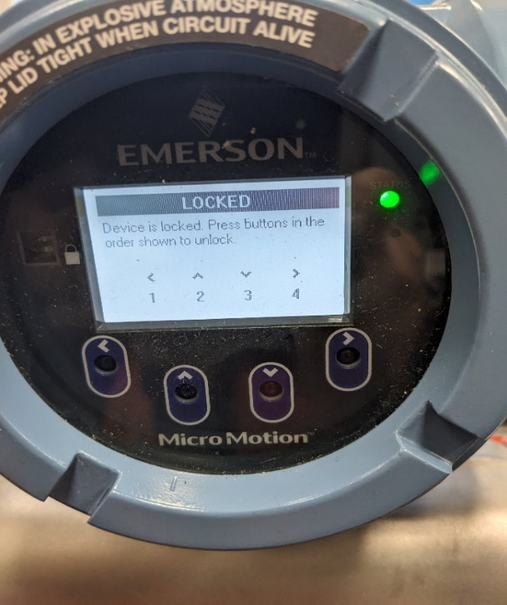
To activate, press the buttons in sequence from left to right: 1, 2, 3, and 4
“Output saturated” message
Since the analog output has a limited measurement range, to improve the accuracy of the flow measurement at zero, the message “Output saturated” will appear during normal operation; simply acknowledge the alarm using the left button.
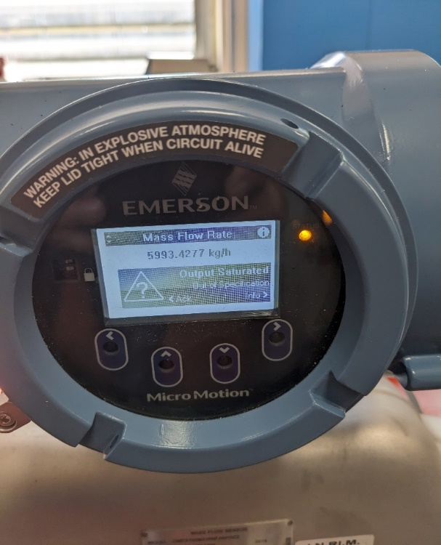

Zero the meter
Prepare the meter:
a) After applying power, allow the meter to warm up for at least 20 min.
b) Allow the process medium to flow through the sensor until the sensor temperature reaches the normal process operating temperature.
c) Stop the flow through the sensor by first shutting the downstream valve and then, if present, the upstream valve.
Use the buttons to select the zero-point adjustment function:
Menu → Service Tools → Verification & Calibration → Meter Zero → Zero Calibration

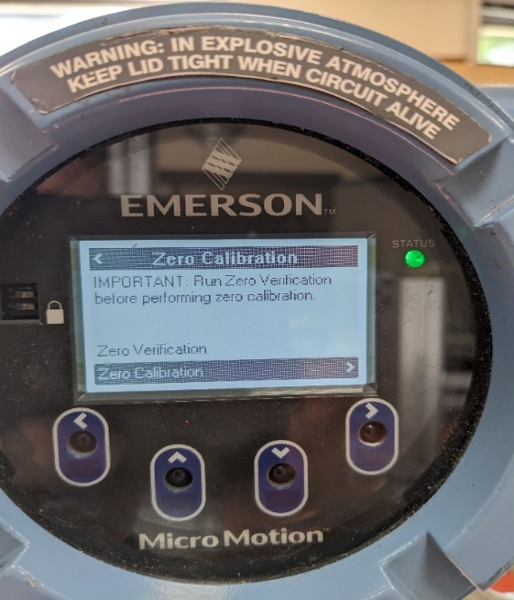
d) Check Zero Time
Zero Time controls the amount of time the transmitter takes to determine its zero-flow reference point. The default zero time is 180 s.
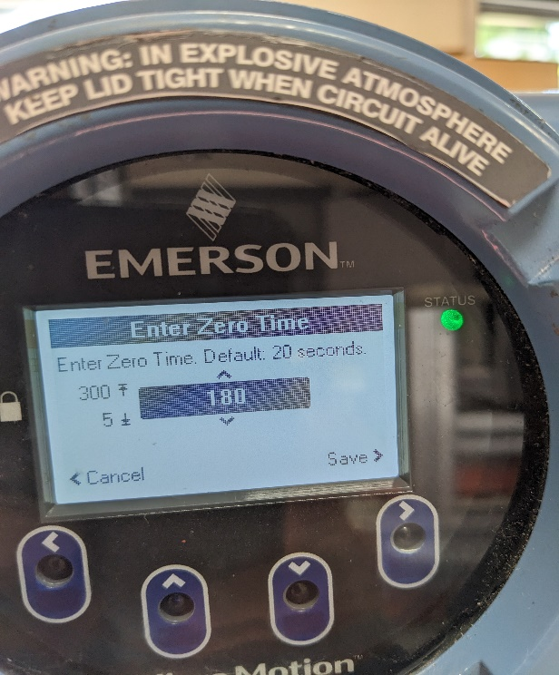
3. Start the zeroing procedure and wait until it has finished.
When the calibration is complete:
• If the zero procedure was successful, a Calibration Success message and a new zero value are
displayed.
Press the button to Continue and after Finished

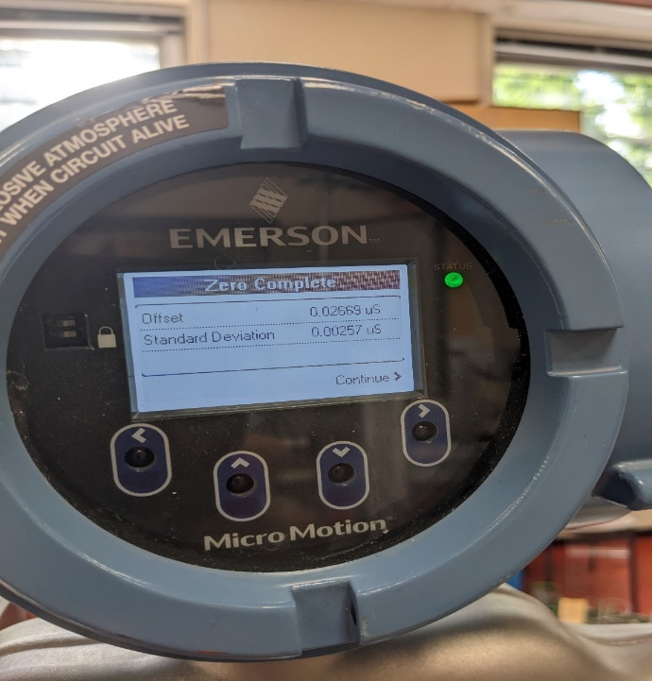 | 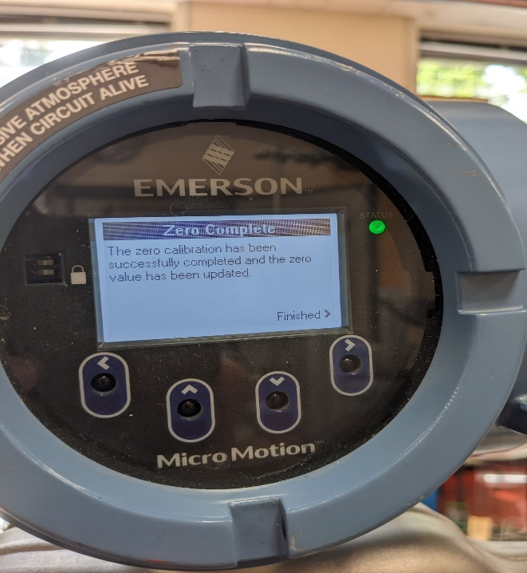

• If the zero procedure failed, a Calibration Failed message is displayed, in this case, repeat the procedure
Configure the Outputs (Set Power internal or external)
Use the buttons to select the pulse output Channel
Channel A for the current output
Channel B for pulses for the volume
Channel C for pulses for mass
Menu → Configuration → Inputs/Outputs → Channel A, B or C.
For example Channel C
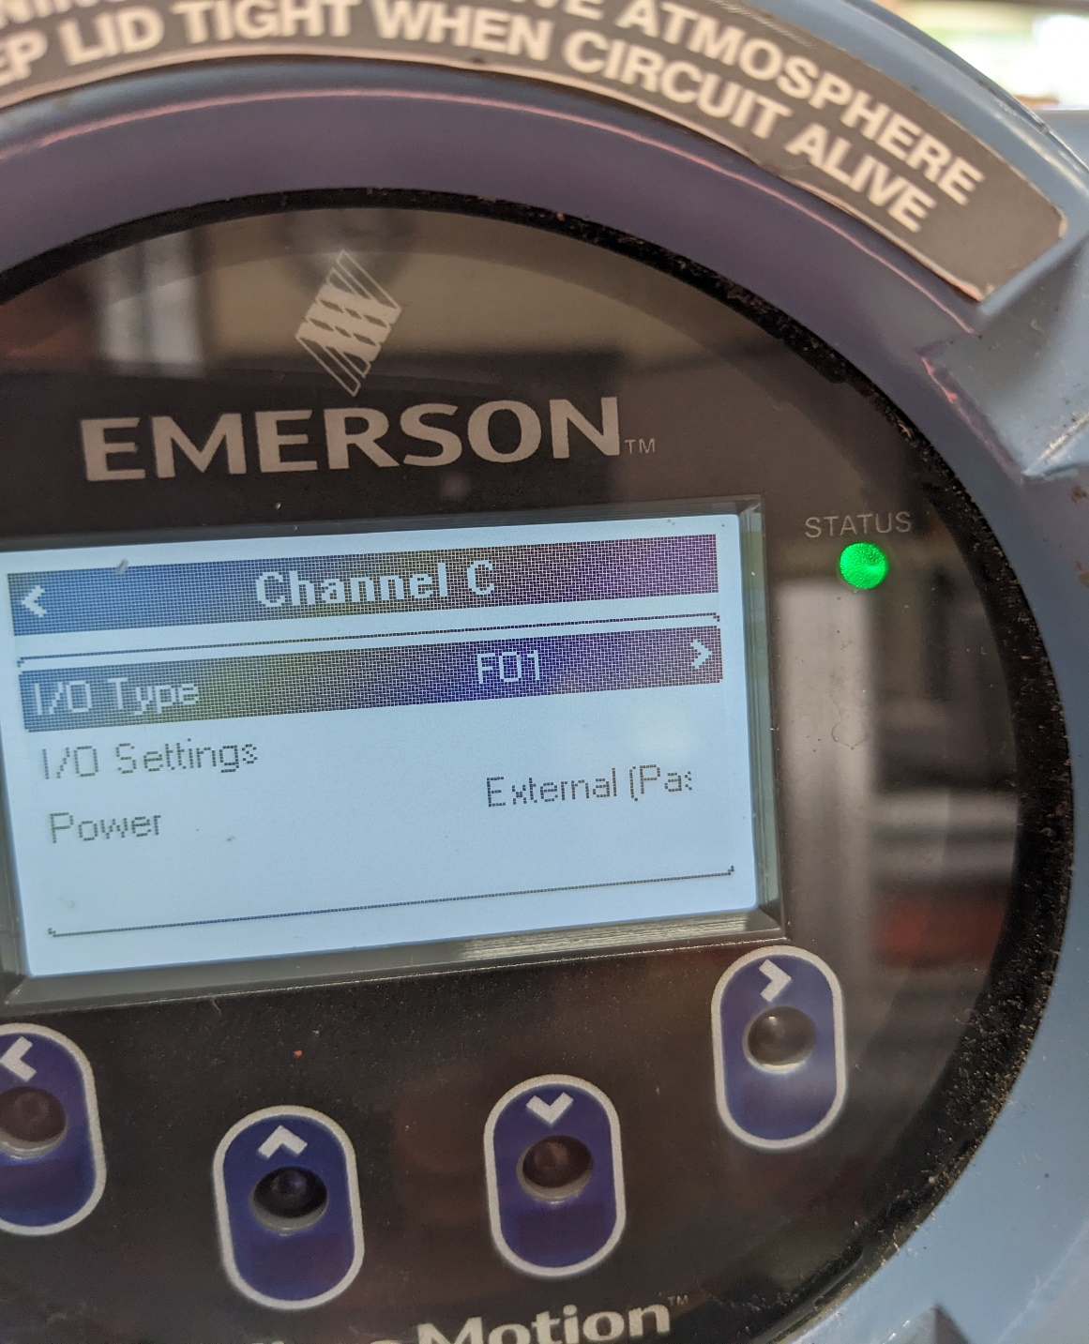
Select Power to change internal or external
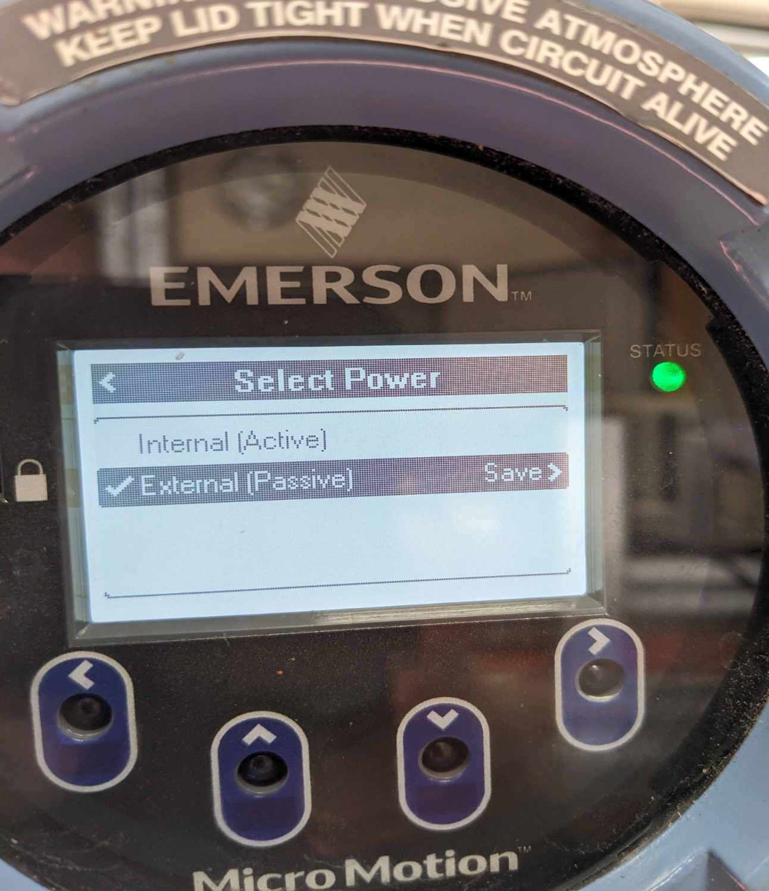

To save your changes, hold down the right button (Save)
Check the Factor Meter
Menu → Configuration → Process Measurement → Flow Variables → Mass Flow Settings → MeterFactor
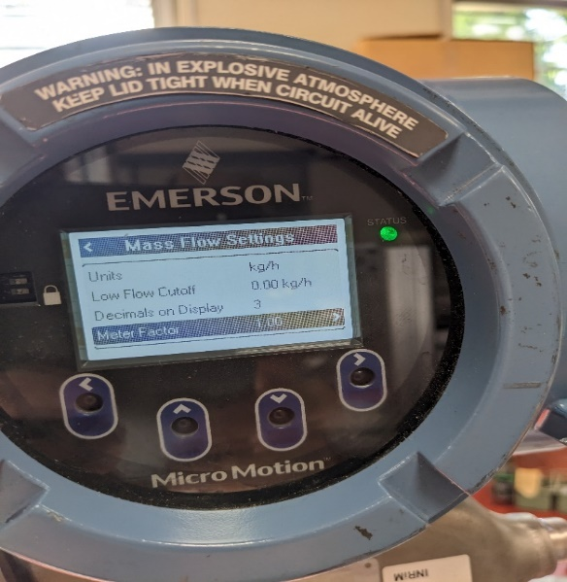
Select Meter Factor
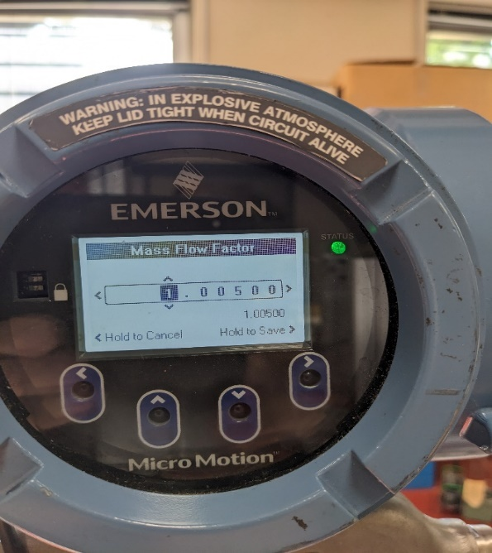

Check the Output configuration
Menu → Configuration → Inputs/Outputs → Channel A, B or C
For example for the Channel C
Select I/O Setting

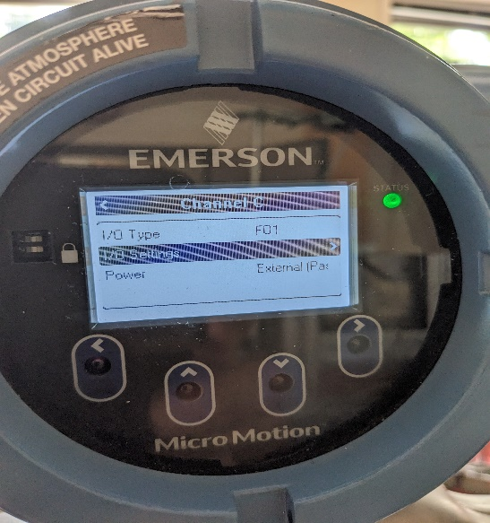 | 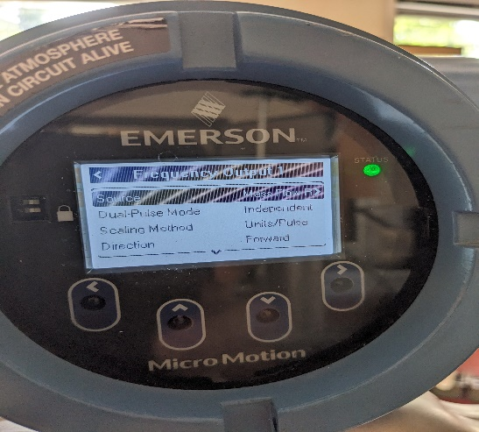

Select Units/Pulse
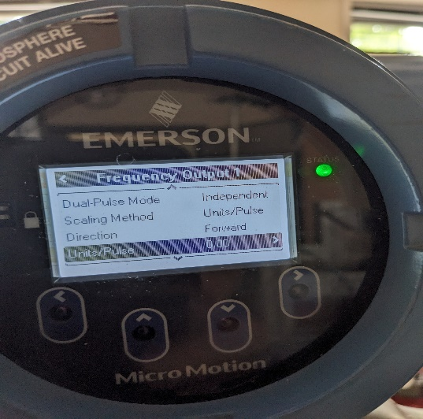
Read the value
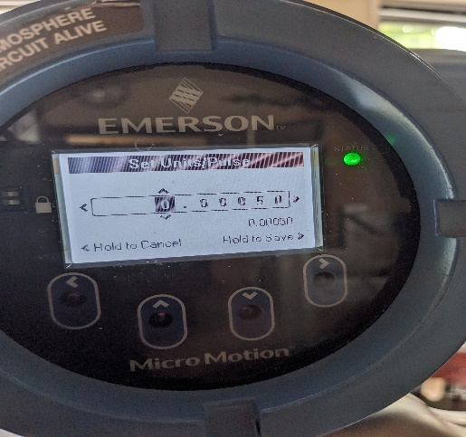
Press and hold the left button to exit.

