EURAMET project Comparison

Calibration of Infusion Device Analysers

Technical Protocol

Coordination Elsa Batista
IPQ-DMET - Volume and Flow Laboratory

September 2025

Content

Objective 3
Procedure 3
Standards 3
Measurement procedure 3
Ambient conditions of the measurements 4
Calibration points 4
Participants and planning 4
Presentation of results 5
Uncertainty 6
Result analysis 6
Final evaluation procedure of comparison data for decision table 7
References 7
Annex 1 – IDA instructions of use 8
Annex 2 16
Annex 3 17

Objective

The purpose of this comparison is to verify the agreement of results and uncertainties in the calibration of an Infusion Device Analyser. These instruments are used to verify the accuracy of drug delivery devices by the users or maintenance officers in the hospitals. The laboratories should follow the new version of EURAMET cg 27 [1] regarding the calibration procedure. This document presents the guidelines for performing this comparison.

Procedure

Standards

An IDA with one channel will be used in this comparison, as described in table 1.

Table 1 – Instrument used in the comparison
Manufacturer | Model | Serial number | Minimum flow rate | Maximum flow rate
Fluke | IDA-1S | 1863594 | 0,5 mL/h | 1000 mL/h

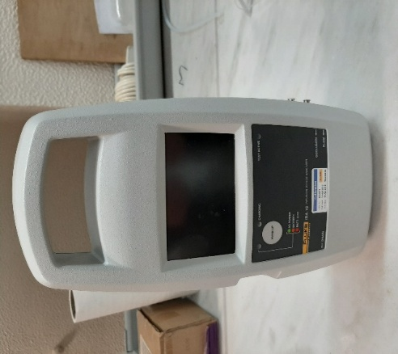
Figure 1 – One Channel IDA

Measurement procedure
The calibration of IDA can be done by the gravimetric method or by the displacement method, as described in EURAMET guide cg 27 [1].

- A measurement of a minimum delivered volume of 10 mL or 20 mL will be necessary depending on the flow rate, but for small flow rates 2 mL will be sufficient.
- The IDA should be switched on and left for at least 6 hours in the laboratory to stabilise the internal temperature which is affected by the heating effect of the electronics in the IDA.
- The starting of the test should be done after stabilization of the system and the priming of the IDA has ended (indication on display and no bubbles inside).
- 5 flow points will be tested with 3 repetition each.
- The measurand is the average flow rate read in the IDA.
- The data can be collected using the IDA software. (see annex 1)
- Water and ambient temperature, relative humidity and atmospheric pressure have to be recorded during the calibration.

Ambient conditions of the measurements

The ambient conditions of the laboratory room during the measurements should be the following:
- humidity higher than 50 %,
- ambient temperature between 17 ºC up to 23 ºC,
- the water temperature must be near the air temperature and shall not vary more than 0,5 ºC during the measurements,
- It is recommended to use degassed water.

Calibration points

- 1 mL/h (minimum 2 mL volume)
- 10 mL/h (minimum 10 mL volume)
- 50 mL/h, 100 mL/h and 500 mL/h (minimum 20 mL volume)

Participanting NMI's and time schedule
The participanting NMI's and time schedule are shown in Table 2, each laboratory has one week to perform the measurements and one week to send the instrument to the next laboratory. Each laboratory is requested to arrange the transport to the next Institute and therefore pays for the cost of shipment of the package to the next laboratory. It is mandatory to include in each shipment order an insurance of 15 000 € for the IDA.
After arrival of the transfer standard, the participating institute shall inform the pilot by e-mail (ebatista@ipq.pt). Immediately after receipt a visual inspection should be made. The participating institute shall check the instrument for any damage. The pilot should be informed about the arrival and departure dates and about the results of the visual inspection as soon as possible, by e-mail.

Table 2: Participants and time schedule for partners
Institute | Country | Shipping address | Contact/mail/phone | Date
IPQ | Portugal | Instituto Português da Qualidade (IPQ). Rua António Gião 2 2829-513 Caparica | Elsa Batista  ebatista@ipq.pt | September 2025
RISE | Sweden | RISE Research Institutes of Sweden AB, Brinellgatan 4, 504 62, Borås, Sweden | Oliver Büker  oliver.buker@ri.se | September  2025
METAS | Switzerland | Federal Institute of Metrology  Hugo Bissig  Lindenweg 50  CH-3003 Bern-Wabern | Hugo Bissig  Hugo.Bissig@metas.ch | October 2025
CMI | Czech Republic | Czech Metrology Institute  Okruzni 31, 63800 Brno | Miroslava Benkova  mbenkova@cmi.gov.cz | October2025
IPQ | Portugal | Instituto Português da Qualidade (IPQ). Rua António Gião 2 2829-513 Caparica | Elsa Batista  ebatista@ipq.pt | November 2025

Presentation of results
It is requested to send the results to pilots within 15 days after the tests have been performed. Further, the participants are requested to use Annex 3 and the table 3 to report on the individual measurement results. This table has the following layout:

Table 3: Measurements results – for each TS
Reference flow | Mean water temperature | IDA mean average flow | Mean relative error | Expanded  uncertainty (k = 2)
(mL/h) | (°C) | (mL/h) | (%) | (%)

The relative error of the transfer standard $ε$ in % is the quantity that will be used to compare the results. It is defined as the difference between the mass flow rate indicated by the transfer standard and the mass flow rate according to the reference:

$ε=\frac{Q_{IDA}-Q_{ref}}{Q_{ref}}·100\%$ (1)
where:
$ε$ is the relative error of the transfer standard in %,
$Q_{IDA}$ is the average flow rate in mL/h,
$Q_{ref}$ is the reference flow in mL/h.

Also, a copy of the IDA pdf data should be supplied to the pilot laboratory.

The laboratory has to describe the equipment used for the calibration and its traceability – see example in Annex 2.

Uncertainty

The uncertainty budget should be performed according to the Guide to the Expression of uncertainty in measurement [2].

Result analysis

To determine the reference value the formula of the weighted mean will be used, using the inverses of the squares of the associated standard uncertainty as the weights [3]:

(2)

To determine the standard deviation u(y) associated with y:

(3)

The results analysis will be performed according to the En number [4]:
(4)

where x_{lab} and U_{lab} are the volume and the uncertainty obtained by the laboratory and, xref and U_{ref} are the volume and the uncertainty obtained by the reference.
IPQ will perform two calibrations, one at the beginning and another at the end of the to access the stability of the artefacts.
Absolute values of En ≤ 1 represent a satisfactory performance by the laboratory.

Finally, the chi-squared test [3] is applied to check whether the determined errors and accompanying uncertainties can be expected based on a Gaussian distribution. If so, the y is accepted. The chi-squared test is defined as follows:
$$χ_{obs}^{2}=\sum_{i=1}^{n}{{\left(\frac{ε_{lab i}-ε_{RV}}{u\left(ε_{lab i}\right)}\right)}^{2}}$$ | (5)

where $χ_{obs}^{2}$ is the observed chi-squared value.

The degrees of freedom $υ$ are estimated with:
$$υ=n_{i}-1$$ | (6)

where $n_{i}$is the number of evaluated laboratories.

For data evaluation the CHIINV(0.05;v) function of MS Excel is used. The consistency check fails if CHIINV(0.05;v) gives values < than $Χ_{obs}^{2}$. Note, here $u\left(ε_{lab i}\right)$ is the standard uncertainty (k = 1). The set of measurement results for a certain flow point is only accepted when:

$$Pr\left\{Χ_{v}^{2}>Χ_{obs}^{2}\right\}<0.05$$ | (7)
where $Χ_{v}^{2}$ is the chi-squared test value.

If consistency check of Equation (7) passes, $y$ is accepted as the Comparison Reference Value $ε_{CRV}$ and $U(y)$ is accepted as the expanded uncertainty $U\left(ε_{CRV}\right)$. If the test of Equation (7) fails, the laboratory with the highest value of ${\left(ε_{i}-y\right)}^{2} / u_{ε,i}^{2}$is excluded for the next evaluation round. New values of $y$, $U(y)$ and $χ_{obs}^{2}$ are calculated and the consistency check of Equation (7) is repeated.

Final evaluation procedure of comparison data for decision table

For final data evaluation and decision table the following criteria will be used:
- Chi-squared test - Data evaluation and consistency check, based on Equation (5) to Equation (7)
- The participant passes the comparison if En,i $≤$ 1.0
The results of participating laboratory i agrees within 95 % confidence level uncertainty expectations with the CRV (k = 2). The calibrations are conclusive.
- The participant passes the comparison at “warning level” if 1.0 < En,i $≤$ 1.2
- The participant fails the comparison if En,i $>$ 1.2. The claimed laboratory results cannot be accepted.
- Inconclusive results if En,i $≤$ 1.2

References

- EURAMET cg 27 - Guidelines for the Calibration of Drug Delivery Devices and Infusion Device Analysers | TC-F | Version 1.0, 02/2024
- JCGM 100:2008 - Guide to the expression of uncertainty in measurement (GUM). (1993, amended 1995) (published by ISO in the name of BIPM, IEC, IFCC, IUPAC, IUPAP and OIML)
- M.G. Cox, The evaluation of key comparison data, Metrologia, 2002, Vol. 39, 589-595.
- ISO 13528:2005 - Statistical methods used in proficiency testing by interlaboratory comparison

Annex 1 – IDA instructions of use
- Connect power cable to the device and USB cable to the computer;
- Connect the drain tube to the device, ensuring that the end is not 10 cm below the bottom of the device and that no point on the tube rises more than 10 cm above the inlet channels;
- Fill a 20 mL syringe and connect to the device through the 3-way valve, ensuring that there is no air in the tubing;
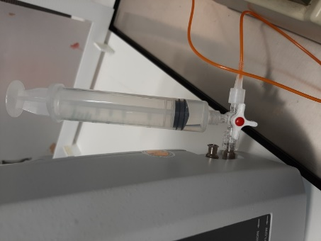
- Connect the machine to be calibrated to the input channel through the 3-way valve, ensuring that there is no air in the piping;

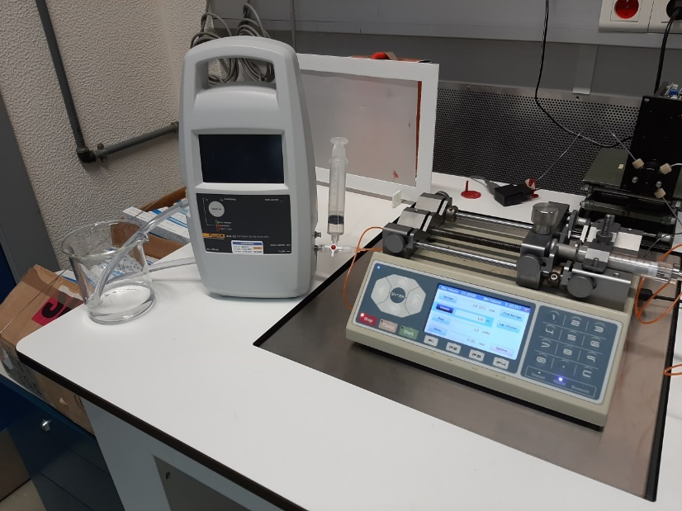
- Change the position of the valve to connect the 20 mL syringe to the device and add water to the system;
- Install Hydrograph application
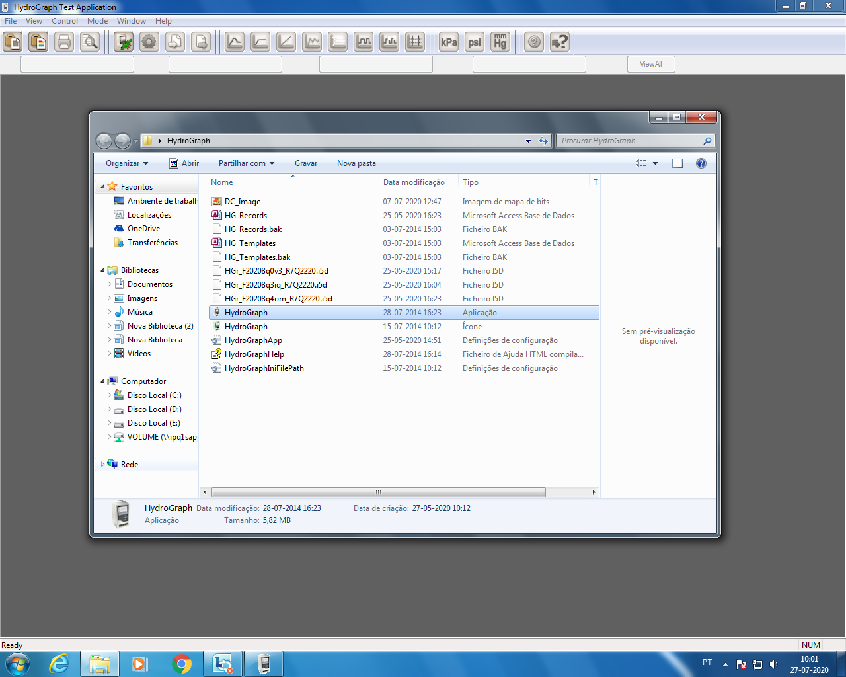
- Turn on IDA1S.
- Start HydroGraph software, click on “Search”, add IDA - 1s through “Add”, and then click on “Connect”; Exit window
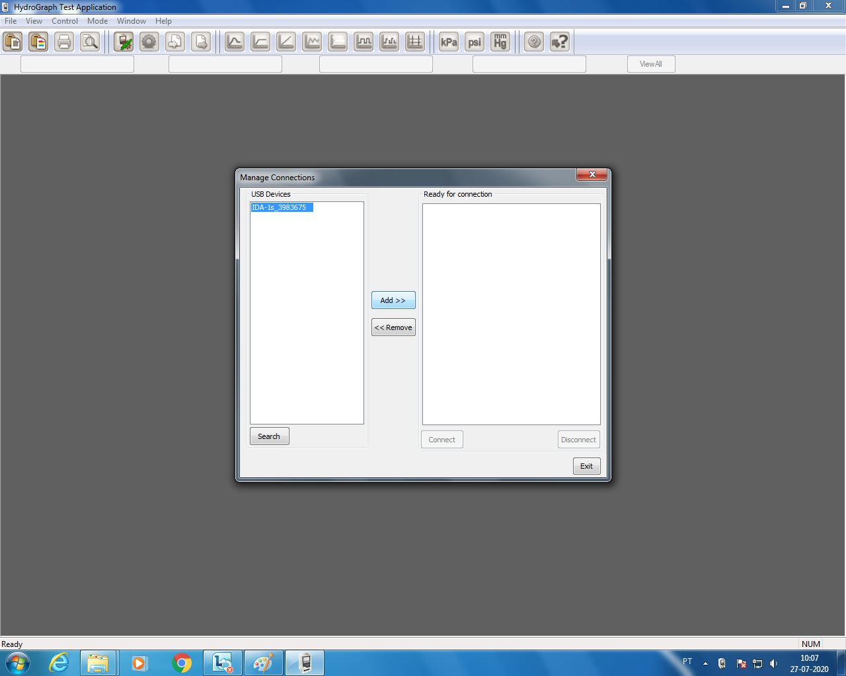
- Click on “Setup Test Details” and fill in the test data, disable “Auto Start”;
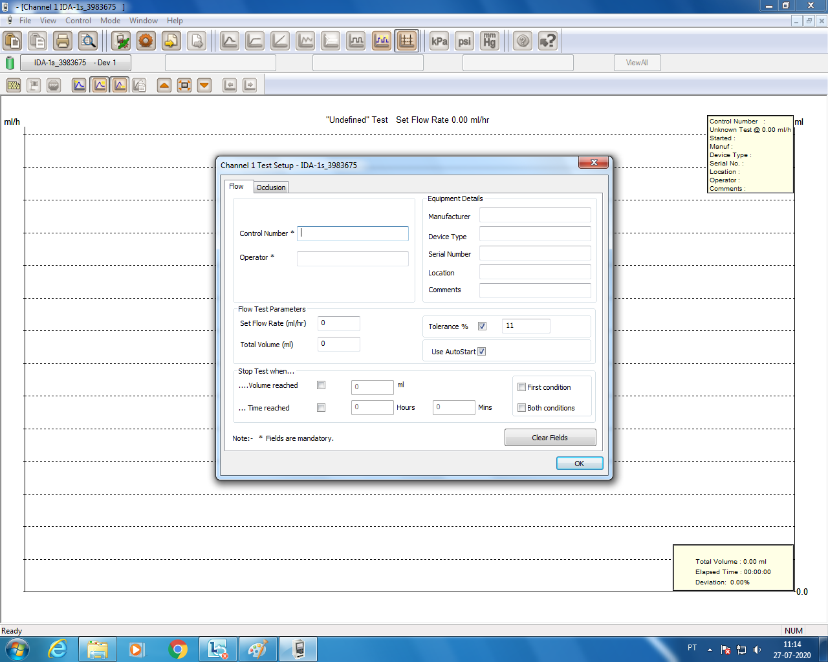
- Prime the system with the 20 ml syringe until green flag on the left appears.
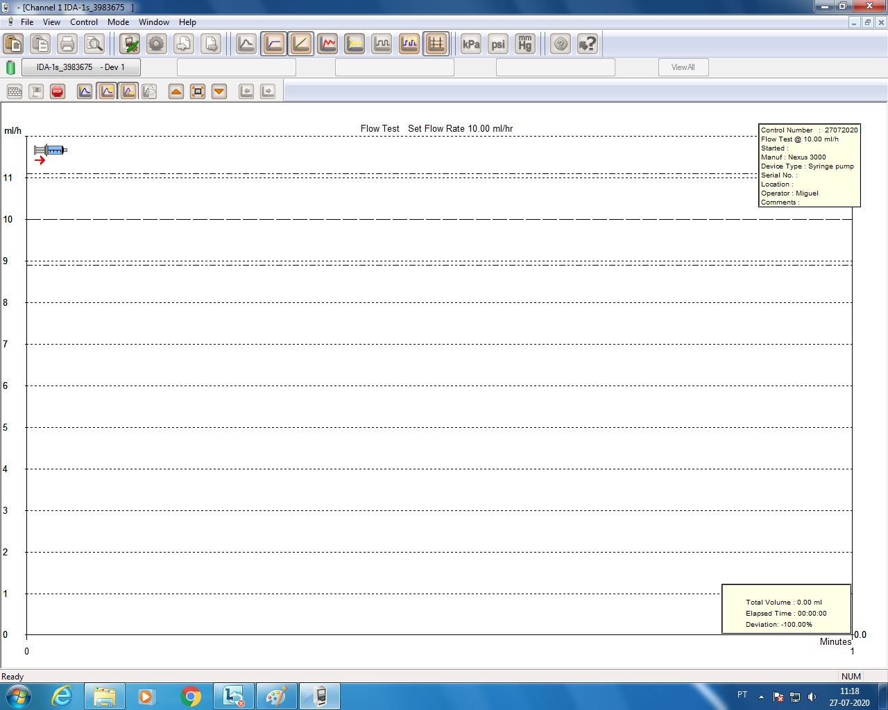
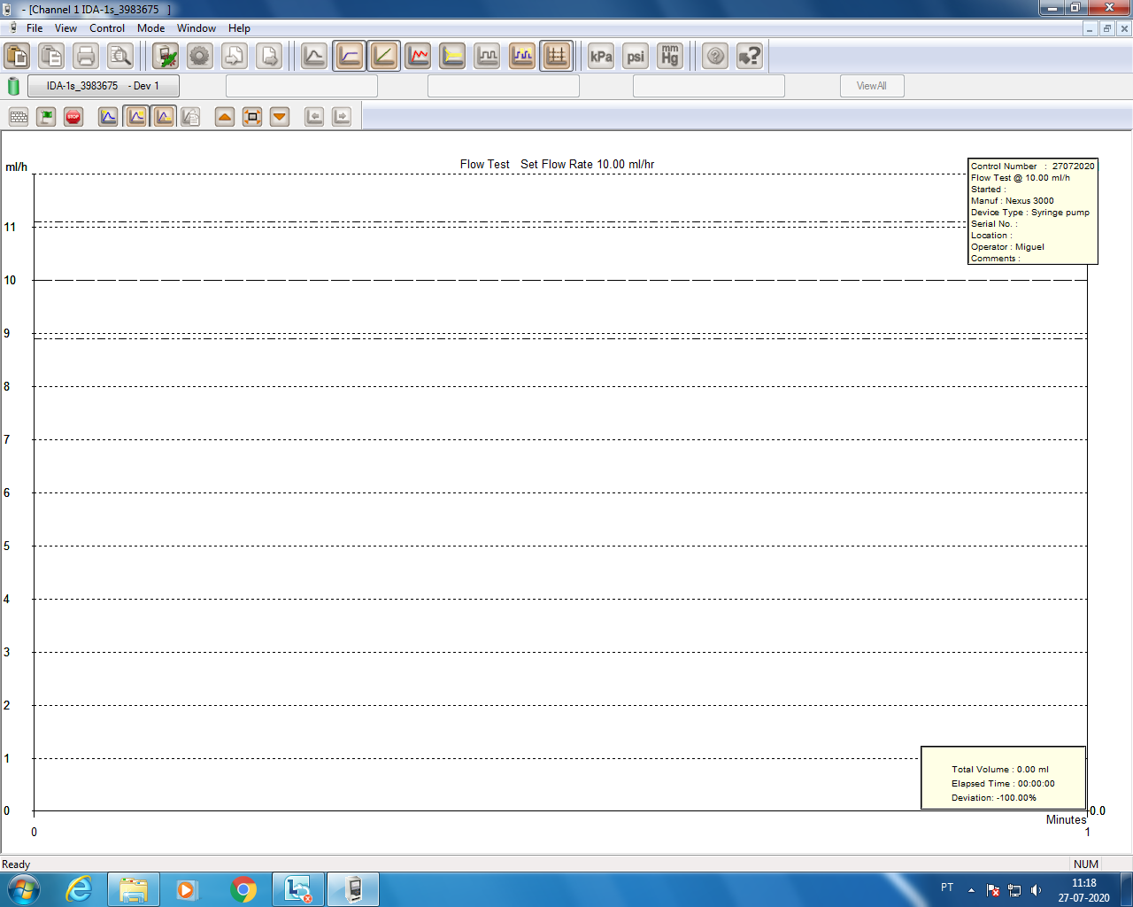
- Change the position of the valve to connect the flow generator to the device;
- Click on the green flag to start the measurement.
Note: It takes some time to get the 1st measurements, up to 10 minutes for the lower flow rates.
To see the instant flow rate click on the Instantaneous flow graph
- When the test ends click on the stop button and record the results, this will be done by printing the data or on file open record.
- To access the table records go to file, open record. Select the test, click ok and the data will be available on the view “data table”.
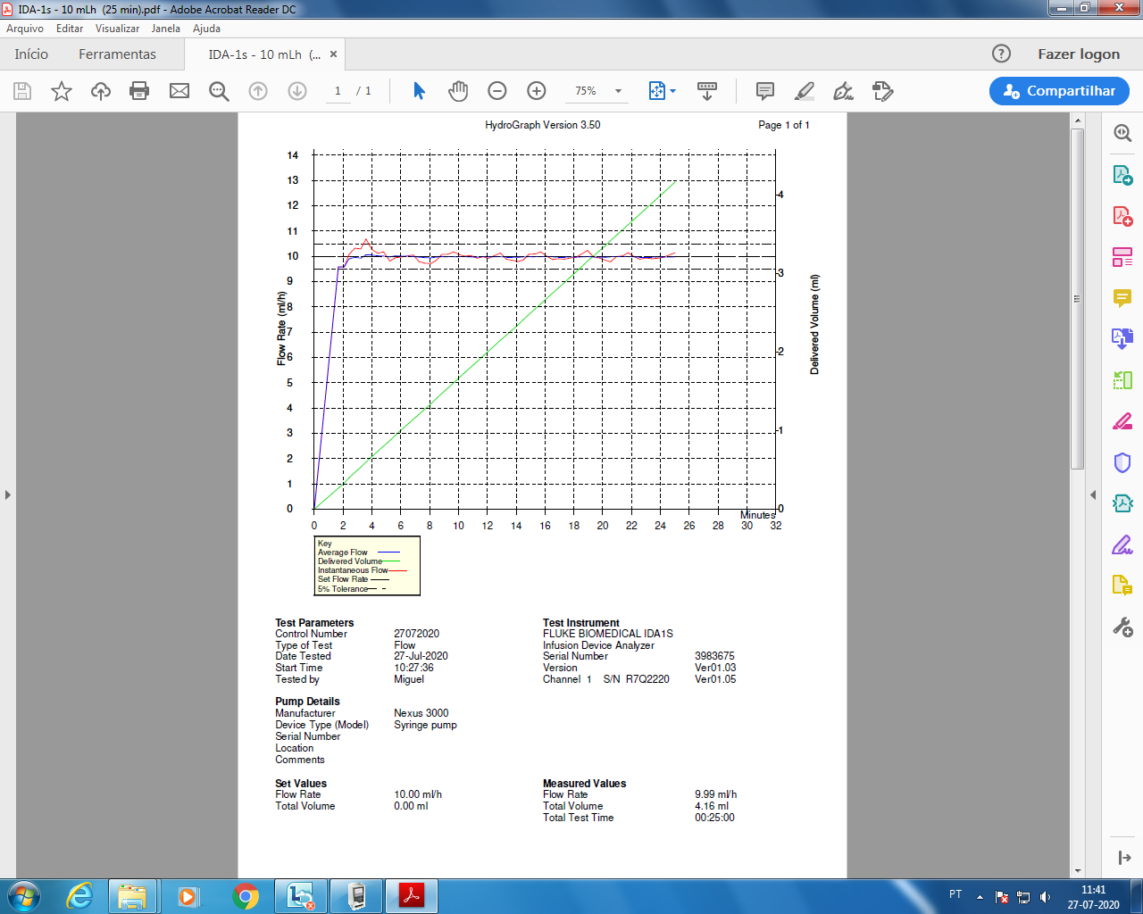
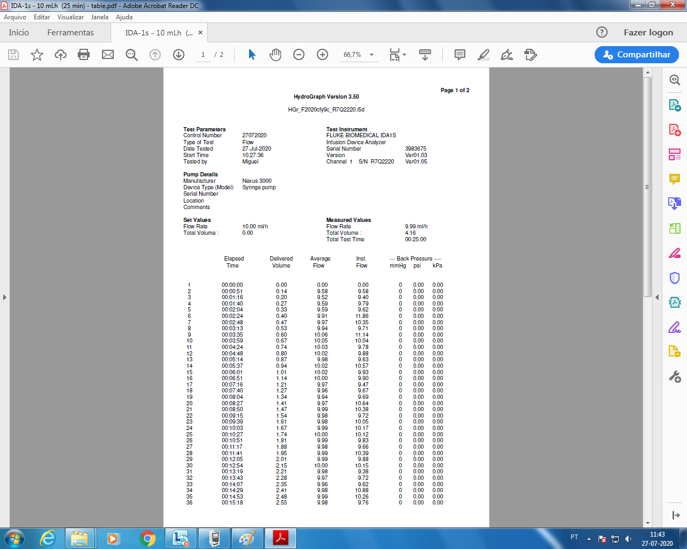

Annex 2
Data Form
General Information
Laboratory
Responsible
Date
Equipment
 | Type | Range | Resolution | Tracebility (when aplied)
Weighing instrument / piston prover/ flow generator
Thermometer
Barometer
Hydrometer
Other equipment
Other Information’s
 | Type | Density reference | Measured conductivity (if the liquid is water)
Calibration liquid
 | Type | Density (if the standard is a mass) | Traceability (when aplied)
Mass standards
Other standards
Calibration method used:

Annex 3
Example: individual results form - Calibration 10 mL/h
Measurement results 10 mL/h
Air temperature (ºC)
Pressure (hPa)
Humidity (%)
Liquid temperature (ºC)
Test number | Average flow mL/h
1
2
3
Mean value
Standard deviation
Uncertainty budget
Quantity (x_{i}) | Value | Distribution | Standard uncertainty u(x_{i}) | Sensitivity coefficient c_{i} | Uncertainty u(y_{i}) | Comment/ Explanation
 |  |  | Combined Uncertainty (μl)
 |  |  | Expansion factor k
 |  |  | Expanded uncertainty (μl) (k=2)

