[REPORT ID] / [MONTH / YEAR]

EURAMET Project 1723 & 1724

Bilateral key and supplementary comparison of neutron measuring instruments in terms of fluence rate and dose equivalents (H*(10) and H_{p}(10)) in ²⁵²Cf and ²⁴¹AmBe neutron beams in ISO neutron reference fields

Identifier in the BIPM key comparison database (BIPM KCDB):
EURAMET.RI(III)-K1.AmBe
EURAMET.RI(III)-S3

Technical Protocol
(accepted by EURAMET TC-IR and CCRI(III))

Pilot laboratory: STUK

Contact persons:
Jussi Huikari and Reetta Nylund
STUK – Radiation and Nuclear Safety Authority
Jokiniemenkuja 1
01370 Vantaa, Finland
+358 40 8225559/+358 40 152 0941
e-mail: jussi.huikari@stuk.fi, reetta.nylund@stuk.fi

Contents
1 Object and participants 1
1.1 Objective of the comparison 1
1.2 Participants 1
2 Transfer instruments 2
3 Sources 2
4 Measurement Procedure 3
4.1 Radiation qualities and quantities 3
4.2 Reference conditions 3
4.3 Reference value 3
4.4 Determination of the calibration coefficient 3
4.5 Uncertainty budgets 3
4.6 Reporting the results 4
4.7 Evaluation the results 4
5 Course of comparison 4
5.1 Transport and time schedule 4
6 References 5
Appendix I: Complete addresses of the participants (used for shipment) 6
Appendix II. Pictures of transfer chambers. 7

Object and participants
The National Physics laboratory (NPL, United Kingdom) and Radiation and Nuclear Safety Authority (STUK, Finland) have agreed to perform a bilateral comparison of neutron measuring instruments in terms of fluence rate and dose equivalents (H*(10) and H_{p}(10)) in ²⁵²Cf and ²⁴¹AmBe neutron beams in ISO 8529 neutron reference fields. The comparison in terms of fluence is an EURAMET Key comparison and the comparison in terms of dose equivalents (H*(10) and H_{p}(10)) is an EURAMET Supplementary comparison. Comparisons are performed simultaneously.
In the project two transfer instruments will be circulated among participants and both laboratories will report calibration coefficients and their expanded uncertainties for those instruments in terms of fluence rate and dose equivalents. NPL has a primary standard for neutron quantities and respective CMCs. Thus, they will provide a link to the CCRI(III)-K9 and CCRI(III)-S1 and CCRI(III)-S2 comparisons as well as provide the reference value for this comparison. STUK has secondary standards, with traceability to CMI, for neutron quantities.
This technical protocol prepared by the laboratories specifies the procedure to be followed in this comparison. The purpose of a comparison is to compare the calibration results of the participating laboratories, not to require both participants to adopt precisely the same method and conditions of calibration measurement. The protocol, therefore, specifies the procedures necessary for the comparison, e.g. reference conditions, but not the procedures used in the calibration of the laboratories being compared.

Objective of the comparison
The objective of the comparison is to support the ionising radiation measurement capability of STUK for neutron quantities (fluence, H*(10) and H_{p}(10)) and eventually, if succeeding, the future CMC claims for neutron fluence by STUK.

Participants
Table 1 lists the participants. In the Appendix I, the complete contact details for the participants are presented.
Table 1. Participants of the project.
Institute | Country | Contact person | e-mail | Type of standard and traceability
NPL | United Kingdom | Graeme Taylor | graeme.taylor@npl.co.uk | Primary, NPL
STUK | Finland | Jussi Huikari (measurements and data) | jussi.huikari@stuk.fi | Secondary, traceable to CMI
STUK | Finland | Reetta Nylund (reporting) | reetta.nylund@stuk.fi

Transfer instruments
Two instruments will be used as transfer instruments for this comparison. The quantity measured depends on the instrument and quantities are specified for both instruments in table 2. The instruments are a property of STUK, which has stability data for these instruments available. This data can be used if needed to evaluate instrument stability during the comparison. The known feature of Berthold LB6411 is long prewarming before it is stabilised. By repeated measurements we know that about 20 mSv dose will be enough for Berthold to reach count rate plateu and it repeats itself very well on that plateau. No additional instruments (e.g. software for reading instrument output) will be circulated with transfer instrument. The details of the measurement equipment (e.g. technical mode) shall be specified when reporting results.
The technical details of the instruments are in the table 2.
Table 2. Technical data of the transfer instruments.
Chamber type | Berthold LB6411 | DMC 3000
Serial number | monitor:  82042 6231  display:  81772 6745 | base unit: 01A317FC  neutron module: 00315A
Quantity measured and comparison type (K or S) | Fluence (K)  Ḣ*(10) (S) | H_{p}(10) (S)
Reference point | Center of the moderator, diameter of the moderator 25 cm | Indicated on the top and side of the neutron module (see picture in Appendix)
Warm up | Pre-irradiation to ca. 20 mSv, sources can be very close to instrument
Special notes |  | Dose repeated minimum 3 times to reduce statistical fluctuation  Doses (minimum):  2 mSv AmBe  4 mSv Cf

Sources
Both participants have ²⁵²Cf and ²⁴¹AmBe sources in use (Table 3.) and suitable sources will be selected for the comparison.
Table 3. H*(10) dose rates for ²⁵²Cf and ²⁴¹AmBe sources Nov 1st, 2024, at 100 cm distance.
Participant | Dose rate
Participant | ²⁵²Cf [µSv/h] | ²⁴¹AmBe [µSv/h]
NPL | 145 & 39 & 5 | 355.9 & 231.5 & 27.0 & 2.5
STUK | 286 | 280

Measurement Procedure
Both participants will proceed following their own calibration procedure(s) according to their quality management system to determine the calibration coefficients of the transfer instrument in terms of fluence and dose equivalent (H*(10) and H_{p}(10), depending on the instrument type). Both laboratories may add needed correction factors for calibrations and these correction factors shall be reported when reporting results. Both participants shall report the orientation of the source relative to calibrated instruments.

Radiation qualities and quantities
The radiation quality used in the comparison are ²⁵²Cf and ²⁴¹AmBe as described in ISO 8529-1:2021. The quantities used for the comparison is fluence rate, ambient dose equivalent rate (H*(10)) and personal dose equivalent (H_{p}(10)). Conversion coefficients will be from ISO 8529-3:2023

Reference conditions
The DMC 3000 shall be calibrated on appropriate phantom as required according to ISO 8529-3:2023. Water filled ISO slab phantom with outer dimensions of 30 cm * 30 cm * 15 cm shall be used for this purpose. Environmental conditions during calibration shall be as required in ISO 8529 and shall be reported. The reference distance from to source to detector reference point shall be 100 cm. In addition, results with other distances according to laboratory’s procedures can be used and reported.

Reference value
NPL as linking laboratory to CCRI(III)-K9, CCRI(III)-S1 and CCRI(III)-S2 comparisons and having respective CMCs will provide reference value for this comparison. STUK results will be compared to this value.
The reference values will be calculated separately for each instrument and the values reported by STUK will be compared to the reference value by calculating a ratio between calibration coefficients of NPL and STUK, e.g. N_{NPL}/N_{STUK}.

Determination of the calibration coefficient
Both laboratories detail their own procedure or refers to international practices/ guidance followed when performing the calibration. The fluence/dose rates used in calibration shall be reported. Possible dose rate dependency of the dosimeter should be considered. For example, coefficient can be given for different dose/fluence rates. A short description of determining the reference fluence/dose rate shall be included, including significant corrections on measurement result, if applicable.

Uncertainty budgets
In addition to calibration coefficients each participant shall provide a detailed measurement uncertainty budget for each calibration quantity. Each participant shall describe the main components of the uncertainty in the budget in the level of one standard uncertainty and provide the final expanded combined uncertainty, k=2. The detailed uncertainty budget shall be provided in accordance with the Guide to the Expression of Uncertainties in measurements (JCGM, 2008) with corresponding confidence level. Components of the uncertainty budget shall be provided as relative values (%). It is expected that in these measurements, participants achieve the best uncertainty that is regularly available. The report Excel sheet includes an example form for the uncertainty budget, into which each laboratory is recommended to add components according to their procedures.

Reporting the results
STUK as a pilot laboratory will send its results to the CCRI Executive Secretary Vincent Gressier (vincent.gressier@bipm.org) within 3 weeks of completing their measurements. As an additional stability data set for the equipment, the chamber owners’ (STUK’s) follow-up data for each of the chambers might be used.
A common Excel template for reporting the results will be provided to participants in addition to the technical protocol. After STUK has sent its data to CCRI executive secretary, NPL will submit their data to STUK for analysis. NPL will submit their data within 6 weeks of completing their measurements. If there is not enough information available, e.g., uncertainty budgets don’t include all needed components to estimate/calculate degrees of equivalence for the comparison, the pilot laboratory (STUK) reserves the right to contact the participant to obtain the missing details.

Evaluation the results
After the reporting pilot laboratory (STUK) has received all results, the results of the STUK will be evaluated in comparison to NPL’s results as NPL provides a reference value for this comparison. The results will be analysed for single instrument and quantity. In principle, the uncertainties need to overlap that results are considered equivalent.
Further details for data analysis may be discussed among the participants on the basis of the Draft A report.
In the reporting of the results, document “CIPM MRA-G-11: Measurement comparisons in the CIPM MRA, Guidelines for organizing, participating and reporting” will be followed.

Course of comparison

Transport and time schedule
Both laboratories should make all the arrangements for safe transport of the transfer standards once measurements have been completed. STUK is responsible for cost of transportation of the instruments to NPL and back to STUK. The standards won’t be insured by STUK, and both participants are responsible for the good care of the chambers in their facilities and good packing of the chambers for the subsequent shipment. Shipment shall be made using a courier.
The transfer standards are packed in a protection box together with a complete information of the devices (i.e. technical protocol) including information about the manufacturer, type, serial number, size, weight and technical data needed for their operation. The information also includes weight and size of the whole package as well as value of the equipment for customs purposes.
The measurements have started in November 2024 at STUK and the instruments will be shipped to NPL in the end of May 2025. NPL is expected to finish measurements within a one month. STUK’s measurement results are from “first round”, after the instruments are returned from NPL, STUK will perform additional stability checks for the instruments. Table 3 summarises the proposed schedule of the comparison measurements and the course of the comparison events.
Table 3. Prosed schedule for the comparison events.
Institute | Event | Due date
STUK | Finalising technical protocol | March 2025
STUK | Registration of comparison to EURAMET | April 2025
STUK | Measurements, results to CCRI executive secretary | within 3 weeks after measurements
STUK | Shipment of instruments to NPL | End of May 2025
NPL | Measurements | June 2025
NPL | Shipment of instruments to STUK | June 2025
STUK | Stability check of instruments | July 2025
NPL | Results to STUK | within 6 weeks after measurements
STUK | Data analysis, Draft A | within 2 months
NPL | Comments to Draft A | within 1 month
STUK | Draft B available | within 1 month after NPL comments

References
CIPM MRA-G-11, Measurement comparisons in the CIPM MRA
Guidelines for organizing, participating and reporting, version 1.1, 18/01/2021
https://www.bipm.org/documents/20126/43742162/CIPM-MRA-G-11.pdf/9fe6fb9a-500c-9995-2911-342f8126226c

ISO – international Organization for Standardization:
ISO 8529-1:2021 Neutron reference radiation fields. Part 1: Characteristics and methods of production

ISO 8529-2:2000 Reference neutron radiations. Part 2: Calibration fundamentals of radiation protection devices related to the basic quantities characterizing the radiation field

ISO 8529-3:2023 Neutron reference radiation fields. Part 3: Calibration of area and personal dosemeters and determination of their response as a function of neutron energy and angle of incidence

JCGM (Joint Committee for Guides in Metrology). Evaluation of measurement data – Guide to the expression of uncertainty in measurement. JCGM 100:2008, GUM 1995 with minor corrections. First edition, September 2008.

Appendix I: Complete addresses of the participants (used for shipment)

NPL/United Kingdom
Postal address:
National Physics Laboratory
Hampton Road
Teddington, Middlesex, TW11 0LW
United Kingdom

Contact person: Graeme Taylor
Tel:
e-mail: graeme.taylor@npl.co.uk

STUK / Finland
Postal address:
Radiation and Nuclear Safety Authority (STUK)
Radiation Metrology Laboratory
Jokiniemenkuja 1
01370 Vantaa
Finland

Contact person: Jussi Huikari
Tel: +358 40 8225559
e-mail: jussi.huikari@stuk.fi

Appendix II. Pictures of transfer chambers.
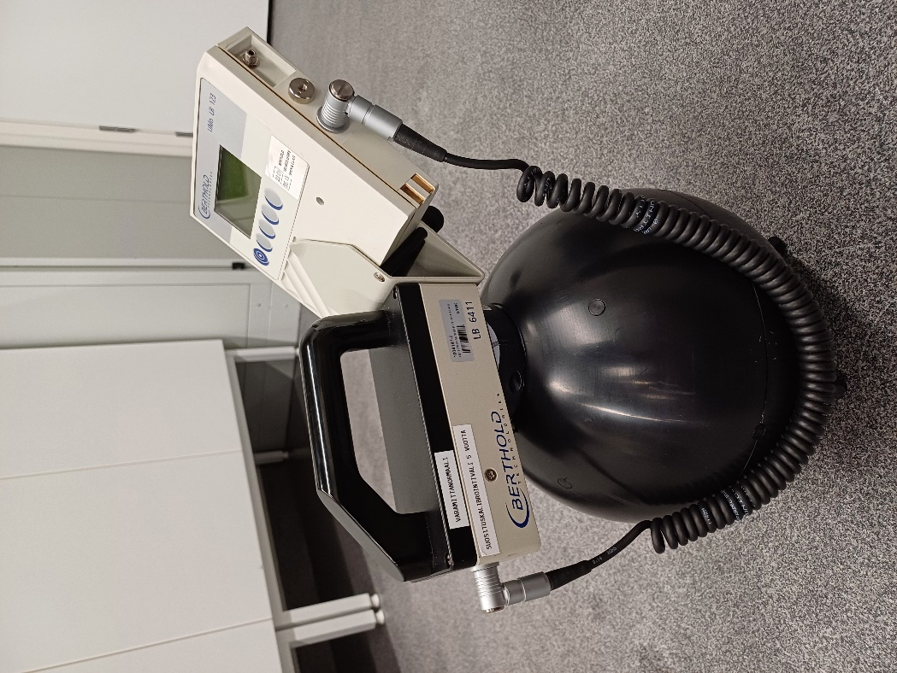
Figure A1. Berthold

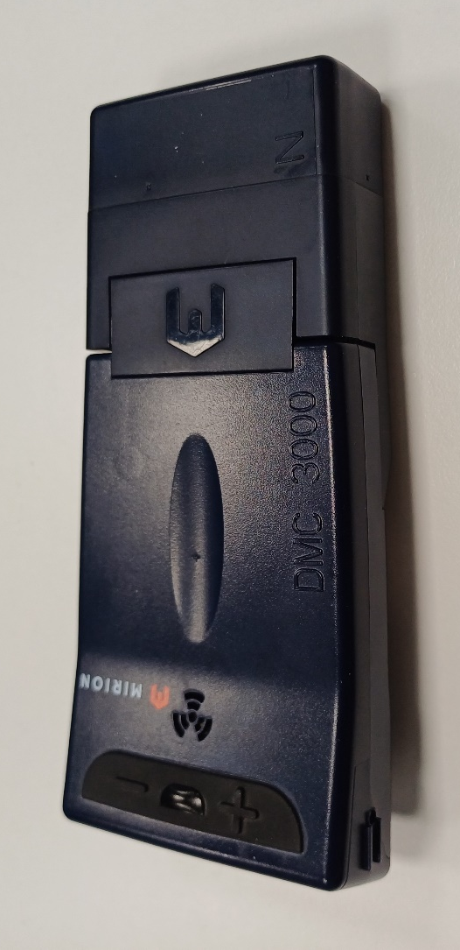
Figure A2. DCM3000 instrument. Reference points are marked with red arrows.

