Welcome to Belgrade!
Here you can find information about transportation from the ,,Nikola Tesla’’ Airport to the Excelsior Hotel.
Hotel Excelsior is located in the very heart of the city centre, just opposite the City Hall and National Assembly. Surrounded by Pionirski and Tasmajdan Park, it is within easy walking distance of the biggest city squares, all major embassies, theaters, old bohemian quater Skadarlija, Kalemegdan Fortress, restaurants and clubs.
BY CAR
1. You can reserve the car transfer from ,,Nikola Tesla’’ airport to the Excelsior Hotel, upon the request, and the rate is 25 EUR per car/transfer (one way). A car has Wi-Fi. There is also opportunity to reserve mini bus for 6 + 1 persons, and the price is 48 EUR per bus (one way).
2. If you want to rent a car from the airport, information about hotel location and directions as well as list of car rental agencies at the airport you can find below.
Coordinates of the hotel: Latitude / Longitude: 44.809823, 20.465563
Hotel Location and directions: http://www.hotelexcelsior.co.rs/location/
List of Car rental agencies at the airport: http://www.beg.aero/en/strana/8961/rent-a-car
If you are coming by car you have possibility for parking in a public and safe underground garage ,,Pionirski park’’. It is just opposite of the Hotel, in front of the City Hall. The hotel has only four ,,parking cards’’ that allows free parking in the afternoon - from 5PM to 8AM the next day. In the period from 8AM to 5PM you need to pay 795 RSD in the garage. For any additional information please contact the hotel.
3. Transportation from the airport to the hotel by taxi is also possible, takes 30 min depending on traffic, and it costs 1800 RSD – second zone, about 15 EUR. If you want to take that ,,fixed price’’ taxi you must go to the desk (in baggage issue) to take a voucher. Taxi brings you straight to the hotel.
Taxi service from airport to the hotel:
http://www.beg.aero/upload/documents/20140318-Taxi_zones.pdf
http://www.beg.aero/upload/Putnici/2015_flajer_taxi.pdf

BY PUBLIC TRANSPORT

If you want to come to the hotel by public transport, there is a mini bus line A1 from ,,Nikola Tesla’’ airport to the ,,Slavija Square’’. The ticket price for mini bus is 300 RSD (tickets can be obtained in the bus). Approximate travel time is around 30 minutes.
Route map and Timetables for bus line A1: http://www.beg.aero/upload/a1_map_&_timetable.pdf
- From Slavija Square you can use a public transport: troll No 19, 21, 22, 29 or bus No 31 from the station ,,Trg Slavija’’ (picture no 1 below) via street Kralja Milana to the station ,,RK Beogradjanka’’ (only one station from ,,Trg Slavija’’). Then, from ,,RK Beogradjanka’’ station (picture no 2 below), take first right to the Kneza Milosa street, up to the Excelsior Hotel (about 350m/ 5 minutes by walk).
- You can also take taxi form From Slavija Square to the hotel. Hotel is located about 1 km away from Slavija Square, which is approximately 5-10 minutes by taxi.
Picture No 1. From Slavija Square and last station of the mini bus line A1, to the station ,,Trg Slavija’’ and public lines: 19, 21, 22, 29, 31 (150 meters/2 minutes by walk)

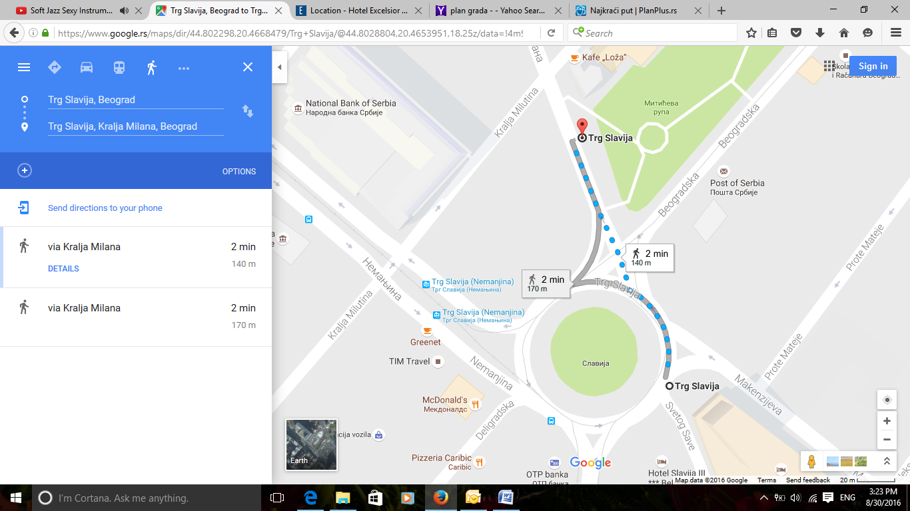
A1

19,21,22, 29,31

Picture No 2. From ,,RK Beogradjanka’’ station to the Excelsior Hotel (350 meters /5 minutes by walk)
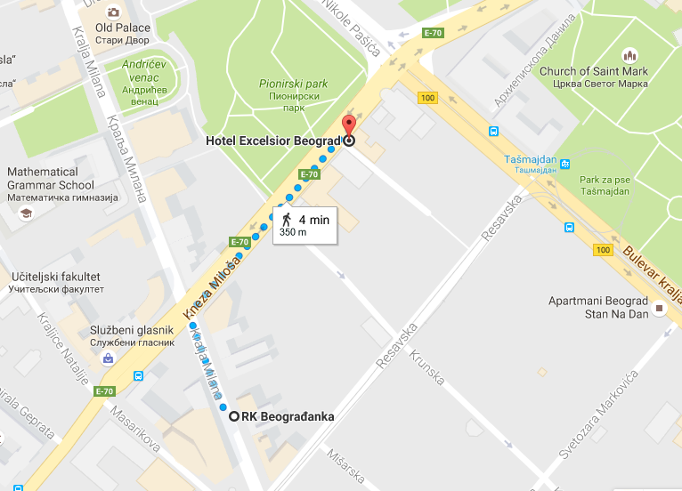
19,21,22, 29,31

Prices of public transport (bus/troll) tickets
There are two types of tickets:
- Ticket that you can buy in the bus/troll for one way and it cost 150 RSD, or
- Daily tickets for zone 1 and 2 at the newsstand. If you choose this option, you will get a card which cost 40 RSD, on which you can ,,make payments’’ of daily tickets: 1 day – 250 RSD; 3 days – 700 RSD; 5 days – 1000 RSD.
- You should know that you may use daily tickets only from 4 AM to 00 PM!

Here you can find links of the alternative hotels close to the Excelsior Hotel:
1. Hotel Constantine the Great, Adress: 27. marta 12, 11 000 Belgrade, Serbia
http://www.constantinethegreatbelgrade.com/hotel/
2. Hotel 88 Rooms, Adress: Takovska 49, 11 000 Belgrade, Serbia
http://www.88rooms.com/
3. Hotel Tash, Address: Beogradska 71, 11 000 Belgrade, Serbia
http://www.hoteltash.com/en/index-2.html

Here you can find some useful links about Belgrade:
http://www.tob.co.rs/
http://www.belgradeeye.com/
http://www.beograd.rs/cms/view.php?id=220
http://www.011info.com/en/

We wish you a pleasant stay in Belgrade!

