EURAMET BoD Working Group for Capacity Building (BoD-WGCB)

3rd Annual Meeting
18th - 19th October 2018
Sofia, Bulgaria

PARTICIPANT REGISTRATION
Personal Details
Title
First Name
Last Name
Organisation
E-mail
Phone
Mobile
Postal Address
Country
The meeting will take place at the CITY Hotel, which is located in the city center of Sofia:
Address: 6 "Stara Planina" Str., 1000 Sofia Center, Sofia

Please send the completed form at latest on 15th September 2018 to:
- BIM, Sofia; e-mail: s.nedialkov@bim.government.bg
- EURAMET Secretariat; e-mail: training@euramet.org

Please indicate parts of the programme in which you intend to participate:
18th October – EURAMET BoD-WGCB Steering Committee Meeting |  | 35 €
18th October – Social Dinner |  | 40 €
19th October – EURAMET BoD WGCB - plenary meeting |  | 35 €

Meeting Fees and Payment
The fee covers: lunch, coffee breaks and conference services
Special dietary requirements:
Registration Accompanying Persons | Dinner | Yes
Fees and dinner for Accompanying Persons 18th October (€40,00).

Payment shall be made by bank transfer to:
BULGARIAN INSTITUTE OF METROLOGY (Account holder)
BULGARIAN NATIONAL BANK
HEAD OFFICE, 1 Knyaz Alexander І Sq., 1000 Sofia, Bulgaria
BIC SWIFT: BNBGBGSD
IBAN: BG88 BNBG 9661 3100 1527 01
Please, indicate “BoD-WGCB” and your name in the bank transfer.
Please add any further information for the issue of the invoice: your VAT number or a payment reference:
Organization name
Address
VAT number (or payment reference)
First Name and Last Name

How to get to City Hotel:
The City Hotel is located in the city center of Sofia, about 11 km from Sofia Airport.

1. Metro
The metro station at Sofia Airport is located in the eastern part of Terminal 2. You can reach it by following the floor markings in blue at the public area of Terminal 2. Sofia Metro Line 1 connects Sofia Airport to the city centre. The journey time is approximately 25-30 min. You need to get off at the metro station “Sofia University St. Kliment Ohridski”. The walk to the hotel is about 10-15 minutes (See map below). One-way ticket costs 1,60 BGN approximately 0,80 €.
Note: International flights are usually from and to Terminal 2. If your flight is to Terminal 1, you can use free-of-charge transportation between Terminal 1 and Terminal 2 at every 30 minutes between 07:00 and 19:00 local time.
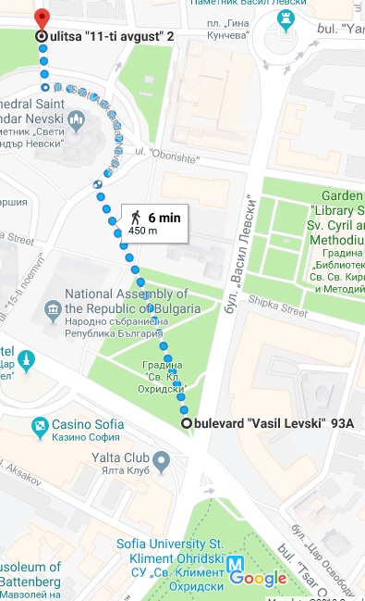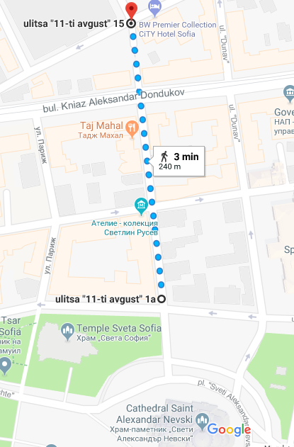
2. You can book shuttle from/to the airport via hotel Accommodation reservation form.
3. Taxi
Next to the airport there is a taxi station (yellow cars “OK supertrans”). If you choose to go by taxi from the airport to the hotel, this will take approximately 20 minutes and it will cost less than 10 €.

