Technical Protocol

Comparison of piston-operated volumetric instruments

EURAMET identifier: 1533
BIPM KCDB identifier: EURAMET.M.FF-S16

1 | Introduction | 3
2 | Participants | 3
3 | General instruction | 4
4 | Transfer standards | 5
5 | The measurement procedure | 6
6 | Uncertainty calculation | 8
7 | Transport and costs | 8
8 | Receipt of the transfer standards | 8
9 | Time table | 9
10 | Reporting the results | 9
11 | Determination of the reference value | 9
12 | Evaluation of comparison measurements | 10
13 | References | 10
 | Annexes | 11
 | Annex A1. An arrival visual inspection form | 11
 | Annex A2. A departure visual inspection form | 12

Introduction
The CIPM Mutual Recognition Arrangement (CIPM MRA) is the framework through which National Metrology Institutes demonstrate the international equivalence of measurement standards. In this context, BIPM publishes on its homepage a list of Calibration and Measurement Capabilities (CMC-lists) of the institutes which have signed the MRA. Calibration services can, however, only be included if a quality management system according to ISO standard 17025 is established. However, quality assurance and confidence in the capabilities of other laboratories can be ensured by the successful participation in a comparison in which the degree of equivalence with other national metrology institutes or calibration laboratories is determined.

In the last years the comparison for 100 μL piston-operated pipettes was performed as key comparison EURAMET.M.FF-K4.2.2014. During the online EURAMET volume subgroup meeting 2021 it was agreed to start a supplementary comparison (SC) on 50 mL piston burette, 1 mL glass syringe and on 10 μL micropipette.

The comparison will be coordinated by the DMDM as the pilot laboratory with the support of IPQ as co-pilot laboratory.

Laboratories are asked to determine the “delivered“ volume of the volumetric instruments at reference temperature of 20 °C using the gravimetric method.

The reported volumes and associated uncertainties are then supposed to be used for the calculation of the DoE between the participating NMI and the comparison reference value.

DMDM and IPQ will be responsible for evaluation of the results.

Participants
 | NMI | Country | Responsible | Contact
 | DMDM  (Pilot) | Republic of Serbia | Ljiljana Mićić | Email: ljmicic@dmdm.rs  Address: Directorate of Measures and Precious metals,  Mike Alasa 14, 11000 Belgrade,  REPUBLIC OF SERBIA  Phone: +381 11 20 24 423
 | TUBITAK UME | Turkey | Ümit Akçadağ | Email: umit.akcadag@tubitak.gov.tr  Address: TUBITAK Ulusal Metroloji Enstitusu (TUBITAK UME), TUBİTAK Gebze Yerleşkesi Barış Mah. Dr. Zeki Acar Cad. No:1  41400 Gebze KOCAELİ, TURKEY  Phone: + 90 262 679 50 00
 | IMBIH | Bosnia and Herzegovina | Ernad Borovac | Email: ernad.borovac@met.gov.ba  Address: Institute of Metrology of Bosnia and Herzegovina,  Branilaca Sarajeva 25, 71000 Sarajevo,  BOSNIA AND HERZEGOVINA  Phone: +387 33 56 89 12
 | MIRS | Republic of Slovenia | Urška Turnšek | Email: Urska.Turnsek@gov.si  Address: Metrology Institute of the Republic of Slovenia,  Tkalska ulica 15, SI-3000 Celje,  SLOVENIA  Phone: +386 3 42 80 756
 | BFKH | Hungary | Csilla Vámossy | Email: vamossy.csilla@bfkh.gov.hu  Address: Budapest Főváros Kormányhivatala  1124 Budapest, Németvölgyi út 37-39.  HUNGARY  Phone: +36 1 4585 947
 | CMI | Czech Republic | Ing. Miroslava Benková, PhD. | Email: mbenkova@cmi.cz  Address: Czech Metrology Institute, Okružní 31, 638 00 Brno, CZECH REPUBLIC  Phone: + 420 737 877 960
 | GUM | Poland | Ewa Malejczyk | Email: ewa.malejczyk@gum.gov.pl  Address: Central Office of Measures,  Elektoralna 2, 00-139 Warszawa, POLAND  Phone: +48 22 581 9010
 | FORCE | Denmark | Lise-Lotte Grue | Email: llg@force.dk  Address: FORCE Technology,  Park Allé 345, 2605 Broendby, DENMARK  Phone: +45 43 25 01 09
 | RISE | Sweden | Per Wennergren | Email: per.wennergren@ri.se  Address: Research Institutes of Sweden,  Brinellgatan 4, SE-50462 Borås, SWEDEN  Phone: +46 105 16 54 67
 | VSL | Netherlands | Erik Smits | Email: fsmits@vsl.nl  Address: VSL B.V.  Hugo de Grootplein 1, 3314 EG Dordrecht,  NETHERLANDS  Phone: +31 6 100 76 985 (mobile Erik Smits)
 | SASO | Saudi Arabia | Abdulkarim A. Al-shahrani | Email: a.shahrany@saso.gov.sa  - Address: SASO, Riyadh - Imam Saud bin Abdulaziz bin Mohammed Road, the intersection of Prince Turki bin Abdulaziz I Road  BOX 3437 Riyadh 11471, Kingdom of Saudi Arabia  Phone: M +966558243530
 | MBM | Montenegro | Jasna Mudreša | Email: jasna.mudresa@metrologija.gov.me  Address: Bureau of Metrology, Arsenija Boljevića bb, 81000 Podgorica, MONTENEGRO  Phone: +382 67 23 7326
 | IPQ  (Co-Pilot) | Portugal | Elsa Batista | Email: ebatista@ipq.pt  Address: Portuguese Institute for Quality  Rua António Gião, 2  2829-513 Caparica, PORTUGAL  Phone: +351212 94 8167
 | DMDM  (Pilot) | Republic of Serbia | Ljiljana Mićić | Email: ljmicic@dmdm.rs  Address: Directorate of Measures and Precious Metals,  Mike Alasa 14, 11000 Belgrade,  REPUBLIC OF SERBIA  Phone: +381 11 20 24 423

General instructions

Each laboratory will be responsible for receiving the Transfer Standards (TSs), to measure it and send it to the next participant according to the time schedule.
When the standards arrive at the participating laboratory, a visual inspection should be made and the results reported to the pilot laboratory. Each participant should fill the arrival form (see annex A.1) and make photos of each volumetric instrument. This information should be sent to the pilot laboratory by e-mail as soon as volumetric instruments arrive to participant’s lab.
The participating laboratories shall determine the volume of water that each of the volumetric instruments is able to deliver at a reference temperature of 20 °C.
Measurements should be done after an appropriate acclimatization time (at least 24 h after the reception of the equipment).
Each participating laboratory shall ensure suitable source of water in order to make use of any of the formulas or tables.
The excel sheets (Form sheets Micropipette.xls, Form sheets Glass syringe. xls and Form sheets Piston burette. xls) for the measurement results, data for ambient conditions and traceability of the reference standards should be filled in and returned to the pilot laboratory within 5 weeks after the measurements, in both “xls” and “pdf” format. Participant results will not be accepted if the participant do not meet the submission deadline date. According to the schedule, every laboratory will have one month to complete the following activities: a) to receive the TSs, b) to perform the measurements, c) to send the TSs to the next participant.
The pilot laboratory will collect and analyse the results, and report these according to MRA procedures. Draft B report is intended to be a publication for the CIPM Key Comparison Data Base.

Transfer standards

Three different transfer standards (volumetric instruments) were chosen for this comparison:
1) a variable 1-channel electronic micropipette, measuring range (0,2 – 10) μL, manufacturer Biohit (Sartorius), type Picus, ser. number 13008918 (see figure 1),
2) a glass syringe, measuring range (0 – 1) mL, manufacturer ILS, ser. number S1, inner diameter is 4,607 mm, (see figure 2),
3) a piston burette, measuring range (0 – 50) mL, manufacturer Brand, type Titrette, ser. number, 21F89857 (see figure 3).

BIOHIT Picus electronic pipette User Manual is available on website https://solutions.pipette.com/wp-content/uploads/Biohit-Picus-User-Manual.pdf.
The micropipette need to have attached a removable plastic tip in order to aspirate the liquid. DMDM will supply these tips.

The piston burette will be supplied with suitable adapters for any storage vessel.

The micropipette and piston burette used for this comparison are essentially of plastic material with a cubic coefficient of thermal expansion of 2,4 × 10⁻⁴ /ºC [3]. This coefficient is linked to the material and is equal for every participant.

The glass syringe has a cubic coefficient of thermal expansion of 9,9 × 10⁻⁶ /ºC [3] and a removable tip is connected to the syringe in order to improve the delivery of liquid, it should not be removed.

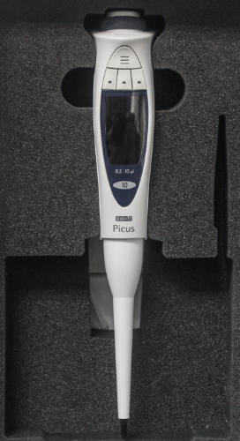 | 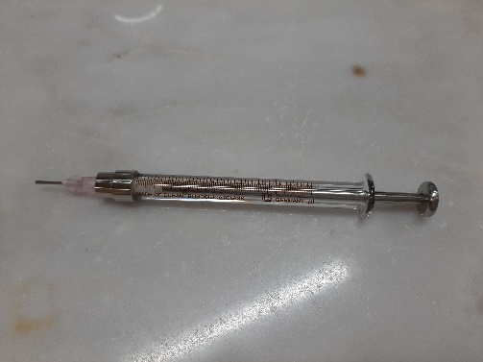 | 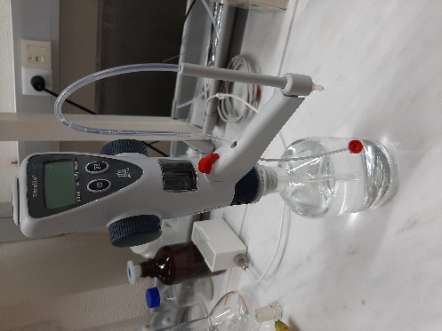
Figure 1 - Micropipette | Figure 2 - Glass syringe | Figure 3 - Piston burette

The measurement procedure

5.1 Getting the volumetric instruments ready for volume measurements

The volumetric instruments must be handled with care, i.e., only by qualified metrology personnel. Avoid any mechanical shock. The instruments must be stored at a place where they are protected from dust, aerosols and vapours.
Each participating laboratory shall make use of its own instruments and procedures in order to measure “delivered” volume. The gravimetric determination of volume is the suggested method.
For temperature uniformity, it is highly advisable to bring the volumetric instruments, the tips and the water to be used in these measurements into the laboratory at least 24 hours before any measurement is performed, at a temperature near 20 ºC.
Picus electronic pipette has eight (8) pipetting modes and five (5) mode related additions. Everybody have to use mode “pipetting” (press menu – adjustment wheel turn on pipetting – press OK) without selected related additions. Micropipette speed range for aspiration and dispensing can be from 1 (slow) to 9 (fast). Everybody have to use speed of aspiration 5 and speed of delivery 5 (press edit – press next - adjustment wheel turn on 5 for aspiration – press OK - adjustment wheel turn on 5 for delivery – press OK). For volume adjustment press EDIT button and turn on adjustment wheel to set desired volume. Confirm the setting by pressing OK.

5.2 Ambient conditions of the measurements

The ambient conditions of the laboratory room during the measurements should be the following:
- humidity higher than 50 %,
- ambient temperature between 17 ºC up to 23 ºC,
- the water temperature must be near the air temperature and shall not vary more than 0,5 ºC during the measurements.

5.3 Measuring points

Micropipette will be calibrated at three measuring points: 10 µL, 5 µL, 1 µL and 0,2 µL (0,2 µL is not obligatory) .
Glass syringe will be calibrated at one measuring point: 1 mL.
Piston burette will be calibrated at three measuring points: 50 mL, 25 mL and 5 mL.

5.4 Volume determination formula

Calibration of the volumetric instruments will consist of the determination of the amount of water that the volumetric instruments delivers at reference temperature of 20 ºC, using the gravimetric method. The following equation described in ISO standard 4787 [2] and ISO 8655 [1] can be used:

(1)
Where:
V₂₀ volume, at the 20 ºC , in µL
I_{I} weighing result of the recipient full of liquid, in mg
I_{E} weighing result of the empty recipient, in mg
ρ_{W} water density, in mg/ µL, at the calibration temperature t, in ºC, is advisable to use the Tanaka density formula [7]
ρ_{A} air density, in mg/µL
ρ_{B} density of masses used during measurement (substitution) or during calibration of the balance, in mg/ µL
γ cubic thermal expansion coefficient of the material of the volumetric instruments, in °C⁻¹
t water temperature used in the calibration, in °C

5.5 Pressure correction (only for micropipette)

The laboratories should correct for ambient pressure according to the following formula [4]:

$∆V=-V_{t}×ρ_{w}×g×h_{w}×\left(\frac{1}{p_{L,X2}-ρ_{w}×g×h_{w}}-\frac{1}{p_{L,X1}-ρ_{w}×g×h_{w}}\right)$ (2)
Where,
∆V/μL: Volume change that results in the calibration at location X1 over a location X2;
V_{t}/ μL: Volume of the air cushion (437 μL);
g/(m/s²): Acceleration of gravity (9,8 m/s²)
h_{w}/m: Lifting height of the liquid column in the pipette tip (0,03 m);
p_{L,X1}/Pa: Atmospheric pressure at location X1(101325 Pa);
p_{L,X2}/Pa: Atmospheric pressure at location X2;
ρ_{w}/(kg/m³): Water density at X2.

5.6 Calibration procedure

5.6.1 Important details for micropipette calibration according to ISO Standard 8655 [1]

The laboratories may use its calibration procedure, but some important details should be taken into account if the gravimetric method is used in order to avoid large measurements errors:
- The weighing vessel should have a film of water (3 mm) before starting the measurements. The use of a lid or an evaporation trap is advisable;
- Deliver the water from the micropipette to the weighing vessel touching the recipient in an angle of 30º and adding the drop retained at the end of the tip of the micropipette;
- Change tip in each measurements;
- Participant laboratory should perform 10 consecutives measurements;
- The immersion of the tip in the water should be around 3 mm;
- The aspiration of the water from the vessel should be done vertically.

5.6.2 Important details for the calibration of piston burette according to ISO Standard 8655 [1]
The laboratories may use its calibration procedure, but some important details should be taken into account if the gravimetric method is used in order to avoid large measurements errors:
- Air bubbles have to be removed from the piston and from the output cannula;
- After filling remove the first 5 drops.
- Set the display to zero before starting the calibration;
- Operate the handwheels evenly and with both hands at moderate speed to dispense the test liquid up to the desired volume;
- The weighing vessel should have a film of water (3 mm) before starting the measurements.
- At the end of the discharge, turn the handwheels more slowly to precisely adjust the volume;
- Droplets at the end of the cannula belong to the dosed volume and are wiped off at an angle on the weighing vessel;
- Only the precisely dosed, selected volume is to be used. Otherwise the measurement is to be repeated.
- Participant laboratory should perform 10 consecutives measurements.
- Always fill the burette to the top before starting any measurement, including the partial volumes.

5.6.3 Important details for glass syringe
- The weighing vessel should have a film of water (3 mm) before starting the measurements. The use of a lid or an evaporation trap is advisable;
- The aspiration of the water from the vessel should be done vertically;
- Remove the air bubbles by holding the syringe with the nozzle pointing straight up and adjusting the plunger until the fiducial line corresponds to the graduation line of the volume to be delivered;
- Deliver the contents of the syringe into the weighing vessel, touching the delivery end of the syringe tip against the inside wall of the vessel just above the liquid surface at an angle of approximately 30° to 45° and draw it approximately 8 mm to 10 mm along the inner wall of the vessel to remove any droplets at or around the tip orifice;
- Participant laboratory should perform 10 consecutives measurements.

Uncertainty calculation

Each laboratory has to describe in an excel sheet (see section 10), the uncertainty components in order that each laboratory results can be compared on a common basis. Both values, i.e. standard uncertainty and expanded uncertainty shall be stated, along with the relevant coverage factor k.
For the evaluation of the measurement uncertainty, reference should be made to the Guide to the Expression of Uncertainty in Measurement [8] and EURAMET Calibration Guide No. 19 [6].

Transport and costs

Responsibility for transport rests with the preceding laboratory. For the transport the volumetric instruments (micropipette, glass syringe and piston burette) will be packed in a two transportation boxes. Micropipette will be packed in one transportation box and will have ATA carnet because the owner of the micropipette is DMDM, Serbia (see figure 5). Syringe and piston burette will be packed in another transportation box and will have documentation for temporary import – export, because the owner of the equipment is IPQ, Portugal (see figure 4).
The cost of transportation to the next participating laboratory shall be covered by the participating laboratory. The volumetric instruments have to be sent by an international logistic service. As an alternative the artefacts may be hand carried by a member of the participating laboratory.
In case of damage or loss of any of the artefacts the SC will be evaluated as far in the schedule as possible. For insurance purpose, the value of the burette is 500 EUR, of the syringe is 100 EUR and of the micropipette is 500 EUR.

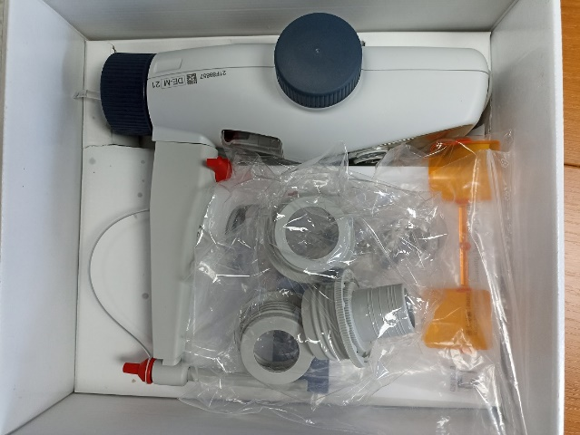 | 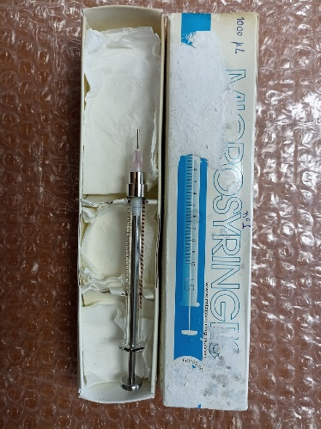
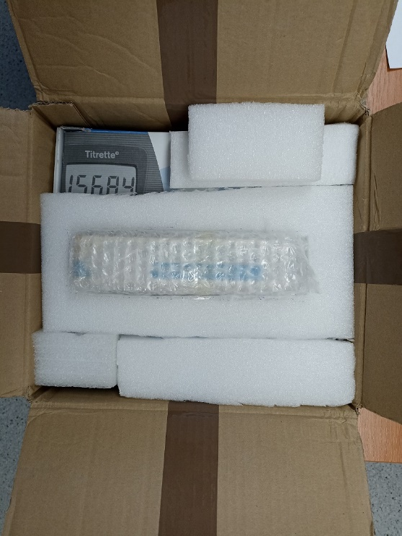 | 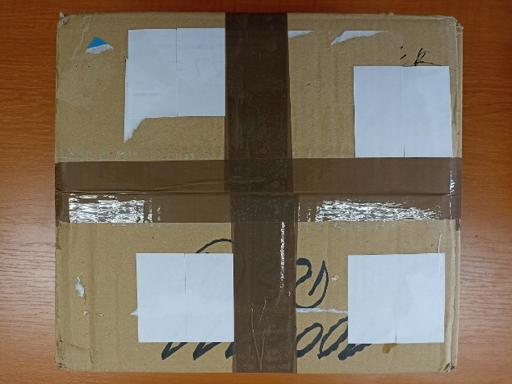
Figure 4 – Transportation box (glass syringe and piston burette)

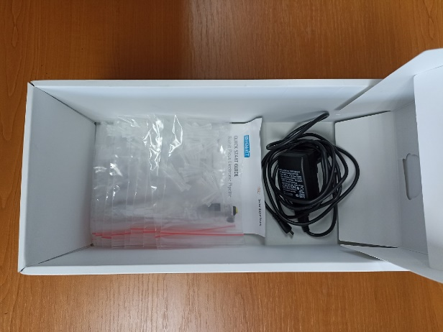 | 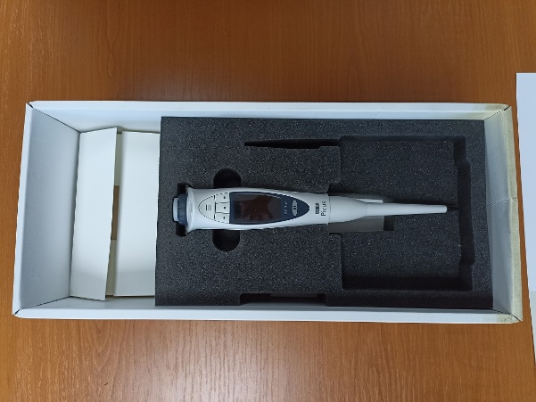
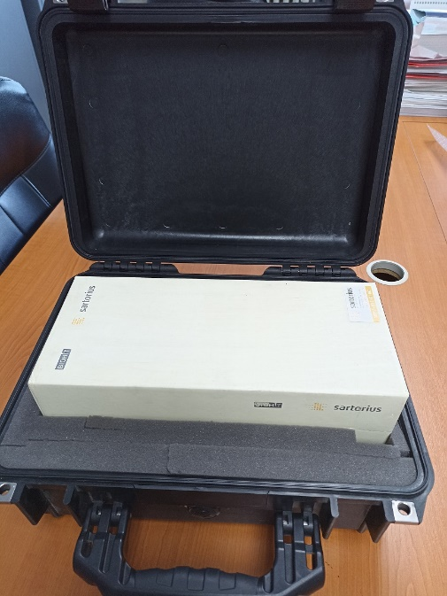 | 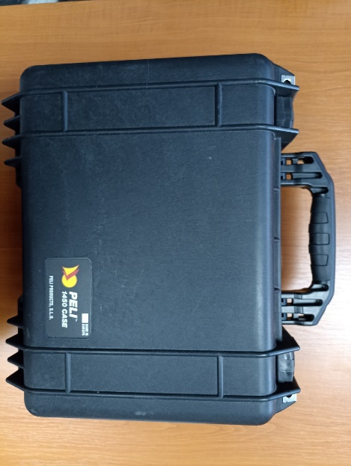

Figure 5 - Transportation box (micropipette)

Receipt of the transfer standards

After arrival of the transfer standards, the participating institute shall inform the pilot institute of this by e-mail. Immediately after receipt a visual inspection should be made and the results be noted on the corresponding formats. The participating institute shall check the volumetric instruments for any damage. DMDM, as the pilot laboratory for this comparison, should be informed about the arrival and departure dates and about the results of the visual inspection as soon as possible, by e-mail using the appropriate form, in Annex A1. In addition a digital photo will be taken.

- Time table

NMI | Country | Responsible | Date for measurements
DMDM  (Pilot) | Republic of Serbia | Ljiljana Mićić | January 2022
TUBITAK UME | Turkey | Ümit Akçadağ | February 2022
IMBIH | Bosnia and Herzegovina | Ernad Borovac | March 2022
MIRS | Republic of Slovenia | Urška Turnšek | April 2022
BFKH | Hungary | Csilla Vámossy | May 2022
ČMI | Czech Republic | Ing. Miroslava Benková, PhD. | June 2022
GUM | Poland | Ewa Malejczyk | July 2022
FORCE Technology | Denmark | Lise-Lotte Grue | August 2022
RISE | Sweden | Per Wennergren | September 2022
VSL | Netherlands | Erik Smits | October 2022
SASO | Saudi Arabia | Abdulkarim A. Al-shahrani | November 2022
MBM | Montenegro | Jasna Mudreša | December 2022
IPQ  (Co-Pilot) | Portugal | Elsa Batista | January 2023
DMDM  (Pilot) | Republic of Serbia | Ljiljana Mićić | February 2023
DMDM Draft A | Republic of Serbia  Portugal | Ljiljana Mićić  Elsa Batista | March 2023

Reporting the results

The results are to be reported to the pilot institute at least 5 weeks after the measurements of the respective participants were completed.
Three excel spreadsheets will be supplied - see Form sheet Micropipette.xls, Form sheet Piston burette.xls and Form sheet Glass syringe.xls - for the presentation of the measurement results, uncertainty components, data for ambient conditions and traceability of the reference standard.
All observations which might be important for the interpretation of the results should be reported.
It is mandatory to send the results in “xls”- and “pdf”-format.

Determination of the reference value

The reference value corresponds to the weighted mean of all participants under consideration of outliers. The methodical approach from Cox (see Metrologia 2002) according to chapter A will be applied. As performance criteria the normalized error will be applied.

Evaluation of comparison measurements

In order to compare the results the value of E_{n} will be calculated. This value represents the deviation between the measuring results of the participating laboratory and the pilot laboratory under consideration of the measuring uncertainty. For acceptable measurements the value of |E_{n}| must be less than 1.
(3)

x_{lab}: Measured value of the participating laboratories;
x_{ref}: Reference value / weighted mean;
U_{lab}: Expanded measurement uncertainty of participating laboratories;
U_{ref}: Expanded measurement uncertainty of the reference value.
The following criteria apply to the acceptance of the measurement results in the context of the comparison measurement:
- |E_{n}| ≤ 1 comparison measurement passed;
- |E_{n}| > 1 comparison measurement failed.

References

- ISO 8655-1/2/3/6:2002, Piston-operated volumetric apparatus;
- ISO 4787:2010; Laboratory glassware – Volumetric glassware – Methods for use and testing of capacity;
- ASTM E542:2000 – Standard practice for calibration of laboratory volumetric apparatus;
- Guideline DKD-R 8-1; Calibration of piston-operated pipettes with air cushion, 12/2011;
- Guideline DKD-R 8-3; Calibration of single stroke dispensers and piston burettes, 03/2020;
- Guidelines on the Determination of Uncertainty in Gravimetric Volume Calibration, EURAMET Calibration Guide No. 19, Version 3.0, 09/2018;
- Tanaka, M., et. al; Recommended table for the density of water between 0 °C and 40 °C based on recent experimental reports, Metrologia, 2001, Vol.38, 301-309;
- JCGM 100:2008; Evaluation of measurement data – Guide to the expression of uncertainty in measurement;
- M.G. Cox, The evaluation of key comparison data, Metrologia, 2002, Vol. 39, 589-595.

Annexes:
Annex A1. An arrival visual inspection form

Arrival visual inspection form
Date of arrival to the laboratory
NMI
Currier
Responsible person
Contact person
Transportation box conditions | GOOD | BAD*
Volumetric instruments conditions | GOOD | BAD*

* Please make a photos and transmit it immediately to the pilot

Annex A2. An departure visual inspection form

PLEASE SEND this form to the pilot and to the next participant

Departure inspection form
Date of departure
NMI
Currier
Responsible person
Contact person
Delivery details | For example: by train no. ....

Photos of volumetric instruments and transportation boxes (Please make several photos)

