EURAMET Project

Cooperation in Research

Evaluation of repeatability measurement procedures in gravimetric volume calibrations of glassware

Technical Protocol

Coordination Elsa Batista
IPQ-DMET - Volume and Flow Laboratory

April 2021

Contents

1. Introduction 3
2. General instructions 3
3. Participants 3
4. The instruments 5
5. The measurement procedure 5
6. Uncertainty calculation 6
7. Transport and costs 7
8. Receipt of the device 7
9. Reporting the results 7
10. References 7
Annex 1 - Reception form 9

Introduction

Following the cooperation between EURAMET TC F and ASTM Committee E41 in the revision of the standard E542 - Standard Practice for Calibration of Laboratory Volumetric Apparatus it was decided to investigate the different approaches regarding repeatability measurements of glassware calibration performed by different National Metrology Laboratories, Accredited laboratories and manufactures around the world and its influence to the determined volume and uncertainty.
Suitable repeatability estimates are needed for evaluating measurement results and for determining the measurement uncertainties. Lack of repeatability agreement within a set of measurement results can lead to significant problems with the operating characteristics of the volumetric instrument.
This protocol describes the different approaches in repeatability measurements from each participant and its impact on the final uncertainty calculation and volume determination. At least two common approaches for obtaining repeatability statistics will be investigated: The first approach uses standard deviation control charts to monitor the measurement process at the time of calibration by ensuring that observed and accepted standard deviations agree. The second approach uses a larger number of repeated measurements for each calibration (5 or 10 replicates).

Two sets of flasks of the following 3 nominal volumes will be calibrated: 100 mL, 500 mL, 1000 mL.

IPQ will be the coordinator of this project and will also act as pilot laboratory in order to establish the stability of the standards.

General instructions

Each laboratory will be responsible for receiving the Transfer Standards (TSs), to test them and send them to the next participant according to the time schedule.
When the standards arrive at the participating laboratory, a visual inspection should be made and the inspection outcome will be reported to the pilot laboratory.
The participating laboratories shall determine the volume of water that the flasks are able to contain (
dry) at a reference temperature of 20 °C.
Measurements should be done after an appropriate equilibration time (at least 24 h after the reception of the equipment).
Each participating laboratory shall ensure suitable quality of water in order to make use of any of the formulas or tables.
The excel sheet, see –Form sheets flasks.xls -, for the measurement results, data for ambient conditions and traceability of the reference standards must be filled in and returned to the pilot laboratory within 15 days after the measurements are completed, in both xls and pdf format.
According to the schedule, every laboratory will have 4 weeks to complete the following activities: a) to receive the TSs, b) to perform the measurements, c) to send the TSs to the next participant.
The pilot laboratory will collect and analyze the results and elaborate the report.

Participants

Country | Laboratory | Responsible | Adress | Contact | Time Schedule
Portugal | IPQ | Elsa Batista | Instituto português da Qualidade  Rua António Gião, 2  2819-513 Caparica | Tel: +351212948167  Email: ebatista@ipq.pt | June 2021
Portugal | Normax | Isabel Faria | NORMALAB  Rua Santa Isabel, 17  2430-475 MARINHA GRANDE PORTUGAL | Tel: +351 244 572 066  isabel.faria@normax.pt | July 2021
Italy | INRIM | Andrea Malengo | INRIM  Strada delle Cacce, 91  10135 Torino  Italy | Tel: +393919 946  a.malengo@inrim.it | September 2021
Slovenia | MIRS | Urška Turnšek | Tkalska ulica 15  3000 Celje | +386 3 428 0756  urska.turnsek@gov.si | October 2021
Germany | ZMK | Olaf Schnelle-Werner (Alt: Ulrich Breuel) | ZMK & Analytik GmbH,  D 06766 Bitteerfeld-Wolfen  Filmstraße 7 | Tel.: +49 349469730  Email: schnelle-werner@outlook.de  analytik@zmk-wolfen.de | November 2021
Greece | EIM | Zoe Metaxiotou | Hellenic Institute of Metrology / National Quality Infrastructure System (NQIS/EIM)  Industrial Area of Thessaloniki, Block 45, 57022 SINDOS GREECE | Tel.: +30 2310 569962  zoe@eim.gr | December 2021
USA | OWM | Georgia Harris  (Alt: Mike Hicks) | 100 Bureau Drive  MS 2600  Gaithersburg, MD 20899 | +01 301-975-4004  gharris@nist.gov  micheal.hicks@nist.gov | January 2022
USA | Artel | George Rodrigues | Artel  25 Bradley Drive  Westbrook, Maine  04092 USA | Tel: 001 207 776 0436  metrologist@grodrigues.net  grodrigues@artel.co | February 2022

The instruments

The chosen instruments are a) one - mark volumetric flasks (see Fig. 1), nominal capacities: 100 mL, 500 mL, 1000 mL, class A, made out of boro-silicate glass, narrow-necked, pear-shaped, manufactured according to ISO 1042:1998.
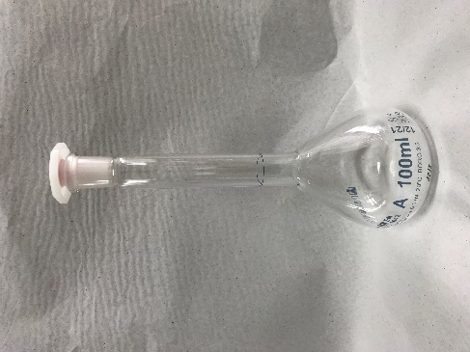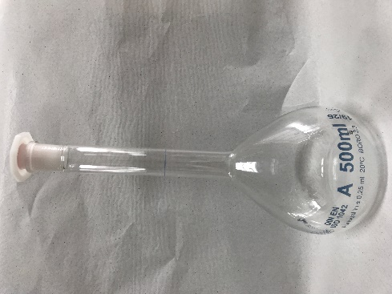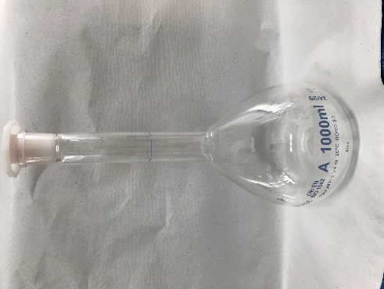
Figure 1 – Flask of 100 mL, 500 mL, and 1000 mL

The measurement procedure

4.1 Getting the flask ready for volume measurements
Two sets of six volumetric flasks comprise the transfer package; all TSs have to be calibrated “to contain dry” the results shall be expressed at a reference temperature of 20 °C.
The flask must be handled with care, i.e., only by qualified metrology personnel. Avoid any temperature shock. The instruments must be stored at a place where they are protected from dust, aerosols and vapours.
Each participating laboratory shall make use of its own instruments and procedures in order to measure water temperature. Gravimetric volume calibration is the suggested method.
For temperature uniformity, it is highly advisable to bring the flask and the water to be used in these tests into the measurement laboratory at least 24 hours before any measurement is performed, at a temperature near 20 ºC.
4.2 Ambient conditions of the measurements

The ambient conditions of the laboratory room during the measurements should be the following:

Ambient temperature between 17 ºC to 23 ºC.

The water temperature must be near the air temperature and shall not vary more than 0,5 ºC during the calibrations.

4.3 Volume determination formula
Calibration of the flasks will consist of the determination of the amount of water contained in the flask at reference temperature of 20 ºC, using the gravimetric method. The following equation described in ISO standard 4787 and in ASTM Е 542 –01: 2002 can be used (NIST SOP 14 is considered equivalent, NISTIR 7383 (2019):

(1)
Where:
V₀ volume, at the 20 ºC , in mL
Ι_{Ι} weighing result of the flask full of liquid, in g
Ι_{E} weighing result of the empty and dry flask, in g
ρ_{W} water density, in mg/μL, at the calibration temperature t , in ºC, is advisable to use the Tanaka density formula [3]
ρ_{A} air density, in g/cm³
ρ_{B} density of masses used during measurement (substitution weighing scheme) or during calibration of the balance, in g/cm³
γ cubic thermal expansion coefficient of the material of the flask, in °C⁻¹
t water temperature used in the calibration, in °C

The participating laboratory should use its own test procedure of calibration. The simplified calibration procedure is:
- Weigh the empty dry standard and record the mass.
- Fill the flask up to the reference line, adjust the meniscus and wipe out (drying) any water drops above the reference line.
- Weigh the filled standard recording the mass .

Meniscus reading
- the meniscus shall be set so that the plane of the upper edge of the graduation line is horizontally tangential to the lowest point of the meniscus.
- the shape of the meniscus is set such that the surface of the liquid forms a curve that meets the glass tangentially.

Uncertainty calculation

Each laboratory must describe in an excel sheet (see section 10), the uncertainty components in order that each laboratory results can be compared on a common basis. Both values, i.e. standard uncertainty and expanded uncertainty shall be stated, along with the relevant coverage factor k. The repeatability measurement procedure shall be described in detail; documented procedures may be referenced if readily available (Euramet cg-19 and NIST SOP 14 provide details).
For the evaluation of the measurement uncertainty, reference should be made to the Guide to the Expression of Uncertainty in Measurement at approximately 95 % confidence interval. [6]

Repeatability measurements
Option 1 – Determine the mean volume of the flask by performing five or ten measurements and determine the standard deviation of the mean value. This option will be performed by the European partners.
Option 2 - Measure the volume of the flask 2 times. Replicates of three may also be used in this approach. A standard deviation control chart is maintained following the NISTIR 7383, Standard Operating Procedure 20 for monitoring and evaluating repeatability over time where a minimum of twenty-five runs is required to establish an accepted standard deviation for the measurement process. When the observed standard deviation meets the statistical criteria, it is included in the laboratory pooled standard deviation and becomes part of the laboratory repeatability representing the measurement process and standard deviation over time. This option will be performed by the US partners.

Transport and costs

Responsibility for transport rests with the preceding laboratory. Responsibility for complying with customs regulations rests with the participants. The value of the flasks for insurance purposes is: 2 000,00 €.
Each participating institute is responsible for its own cost for the measurements, transportation to the next laboratory and any extra customs charges, as well as any damage caused on the flasks during the permanence at the laboratory facilities.
In case of total equipment lost, the project will be interrupted, and the report will be developed based on the results collect until that moment.
In case of some of the flasks are broken the comparisons will continue for the instruments that are still available. The report will be developed based upon presented results.

Receipt of the device

After arrival of the device, the participating institute shall inform the pilot institute of this by e-mail. Immediately after receipt a visual inspection should be made and the results be noted on the corresponding formats. The participating institute shall check the device for any damage. IPQ, as the pilot laboratory for this comparison, should be informed about the arrival and departure dates and about the results of the visual inspection as soon as possible, by e-mail using the appropriate form, in Annex 1.

Reporting the results

The results are to be reported to the pilot institute at least 15 days after the measurements of the respective participants were completed. If this deadline will not be met the corresponding participant will be removed from the project.
An excel spreadsheet will be supplied - see Form sheet flasks.xls - for the presentation of the measurement results, uncertainty components, data for ambient conditions and traceability of the reference standard. A table will the most important components will be supplied.
All observations which might be important for the interpretation of the results should be reported.
It is mandatory to send the results in xls and pdf format. An official calibration certificate must be submitted via PDF as well (noting submitting customer as the pilot laboratory).

References

- ASTM E 542:2021 - Standard practice for calibration of laboratory volumetric apparatus;
- ISO 4787:2020; Laboratory glassware – Volumetric glassware – Methods for use and testing of capacity;
- Tanaka, M., et. al; Recommended table for the density of water between 0 °C and 40 °C based on recent experimental reports, Metrologia, 2001, Vol.38, 301-309.
- Calibration guide DKD-R 8-1; calibration of piston pipettes, 2011;
- ISO 8655-1/2/6:2002, Piston-operated volumetric apparatus;
- BIPM, IEC, IFCC, ISO, IUPAC, IUPAP, OIML; Guide to the expression of uncertainty in measurement (GUM), Geneva, 1995;
- M.G. Cox, The evaluation of key comparison data, Metrologia, 2002, Vol. 39, 589-595.
- Euramet cg 19??
- NISTIR 7383, SOPs 14, 17, 20, GLP 10??

Annex 1 - Reception form

Reception form

Laboratory: |  | Date:
Date of arrival of the transfer standards: |  | From:
Condition of the standards/visual inspection:

Other remarks:

Name of the contact person:
E-mail:

Note: Fill and send it by e-mail to the pilot laboratory upon arrival of the standards.

