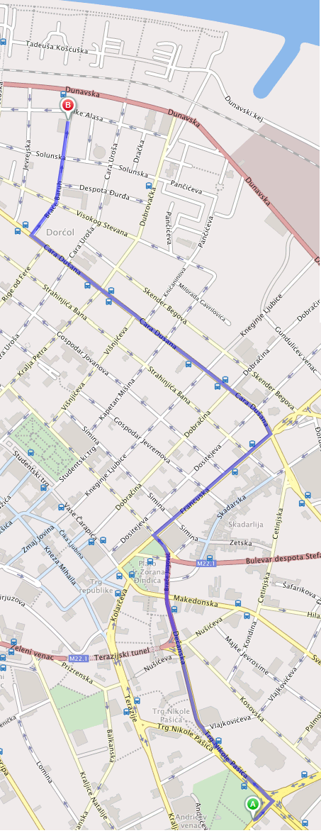
Route by car
A-Excelsior Hotel-Kneza Milosa 5
B-Directorate of Measures and Precious Metals,
Mike Alasa 14, Beograd 11000

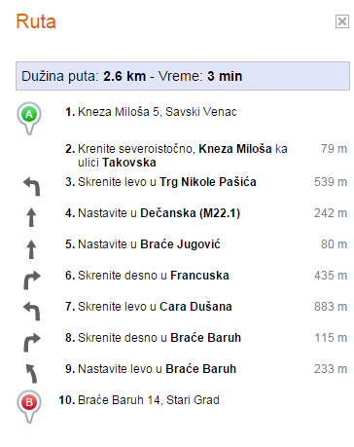

Route by bus No 26
A-Excelsior Hotel-Kneza Milosa 5, Belgrad 11000
B-Directorate of Measures and Precious Metals, Mike Alasa 14, Beograd 11000

